Crime in Portland, Oregon, 2004-2014: A Summary of Trends

Over the past several decades, public awareness of crime has increased significantly. Those who do follow the news are exposed to a constant iteration of stories about illegal activity: local, national, and global. This growing awareness and concern over crime comes at a time where, in many places in the United States, crime rates are actually decreasing and local law enforcement is more effective than ever before in protecting citizens and property from certain criminal activity. In fact, the public has been informed for several years now that crime rates are on the decline, and that in most major cities in the United States there is actually less crime now than there has been for many years.[1] What do the data gathered by law enforcement agencies say about the state of crime over the past several years?

This project offers a direct examination and visualization of the available data for one US city: Portland, Oregon. The exploration will be an initial one, intended mainly to raise questions for further investigation and to identify areas where more information and data would be helpful in answering the questions that arise. Several areas of recent and ongoing interest are also investigated, including the influence on crime rates of such factors as a growing population, unemployment, neighborhood demographic compositions, and startling stories from the local and national news.

General statistics are presented as illustrative of past and present markers of crime rates in Portland, and one hypothesis test is conducted. Unfortunately, due to the complexity of the issues involved, mathematical models describing the data under consideration are usually not appropriate for the scope of this project. While it may have been possible to calculate, for example, a simple linear regression to model a particular situation, it is not clear that a particular model would have been appropriate. Such models may have even supported unwarranted conclusions, or a biased view of the data presented.

Portland

Portland is a convenient city to study: crime data gathered by the Portland Police Bureau are shared openly and publicly, after appropriate measures have been taken to anonymize police records. Currently, data from the years 2004-2014 are easily available. This time span offers the opportunity to examine several possible influences on crime rate, including:

1. Portland’s population grew from about 533,120 in 2004 to about 619,360 in 2014.[2] This represents a 16.18% increase over the course of the eleven years under consideration. Has this influx of population had an influence on Portland’s absolute and relative crime rates?
2. The US economy saw a marked decline between December 2007 and June 2009.[3] Studies (discussed below) have suggested that unemployment and low wages can have a statistically significant influence on crime rates. Was an effect of this kind seen in Portland during the time period in question?
3. People become concerned that certain events that occur on the national or global scale have a direct influence on local crime rates. This project will examine one such concerning event, namely, the events in Ferguson, Missouri on August 9, 2014. Is there any evidence that these events had an influence on crime in Portland?

Definitions

In order to ensure an understanding of the terms and vocabulary used in this project, a broad categorization of crime follows.

* Personal Crimes are those which involve harm to the physical or mental state of a person. These can include assault, battery, false imprisonment, kidnapping, homicide, and rape. In the data under scrutiny for this project, simple assault, aggravated assault, and robbery account for a large percentage of personal crimes (robbery, it should be noted, is classified under both personal crime and property crime).
* Property Crimes are those which involve actions that prevent another person from using or enjoying their property. These can include larceny, robbery, burglary, arson, embezzlement, forgery, false pretenses, and receipt of stolen goods. Property crimes account for the majority (68%) of crimes under scrutiny in this project. In fact, larceny (common theft) alone accounts for more than a third (33.7%) of *total* crime in the city.
* Statutory Crimes are those which violate any federal, state, or local statute. These can include personal and property crimes, and other actions sometimes called “victimless crimes.” Examples include disorderly conduct, DUII, gambling, and selling alcohol to a minor.
* Inchoate Crimes are those which are started, but not completed. These can include any attempted crimes, solicitation, and conspiracy.[4] Portland Police Bureau data obtained for this project does not include inchoate crimes.

Methods

Analysis for this project was completed using the R statistical programming language. Several libraries and packages were utilized as well, including readr, plyr, purrr, sp, dplyr, lubridate, ggplot2, ggmap, mapproj, and several others. A brief description of the data acquisition and cleaning process follows.

Data for this project was collected from the following sources:

* http://www.civicapps.org/datasets: This data is that recorded by the Portland Police Bureau, cleaned, and made available to the public with identifying information removed from each record. Variables such as data and time of report, major offense type, and location information for each incident are provided. For this project, the time of each incident was ignored. Location information was converted from State Plane coordinates to Latitude/Longitude coordinates using the sp library.
* https://data.bls.gov/pdq: This data includes unemployment information for Portland from January 2004 to December 2014. Only the date and unemployment rate columns were utilized.
* https://www.biggestuscities.com/city/portland-oregon: This data includes population (estimates) for Portland for January 1 of each year of interest. No source of information or margin of error is given with the data, so it is accepted without total confidence in its veracity.

It should be noted that the data under consideration do not contain all crimes committed in Portland during the time period in question. Some crimes, of course, are never reported. Other crimes may be reported to agencies different from the Portland Police Bureau, including the Multnomah County Sheriff’s Office. Other crimes may be reported to state or federal law enforcement. For this reason and others, reports compiled by various agencies on crime statistics in Portland may or may not agree exactly with the figures provided in this report. The FBI release of violent crime summary statistics in September 2013,[5] for example, includes statistics that vary from those reported here. An additional reason for variation in statistics reported by various agencies may include differing categorization of various offenses. For example, in the PPB data, “Homicide” is reported as a flat statistic, whereas the FBI has the ability to tease out which homicides were “Murder and non-negligent manslaughter,” as opposed to justifiable homicides or homicides motivated by self-defense.

While there are several methods for calculating a crime index, this paper will focus on examination of the most basic: strict frequency of occurrence. Crime rate per capita will not be included, due to a lack of complete confidence in data supplying Portland’s actual population levels for the time period in question. While a US Census did take place in 2010, other sources that give population levels for each of the years in question are only estimates, and the margin of error for these numbers is unknown.

For similar reasons, examination of crimes occurring in particular areas of the city will take place, but it will be difficult to state with any certainty whether a particular neighborhood has a higher proportion of a specific demographic over the duration of the years of interest. Data from the 2010 census is available, but again, no trends can be identified from this single data point. The relationship between areas of varying demographic heterogeneity and the 2010 crime reports will be examined.

Overview by Category

An overview of crime in Portland can be seen in the graphics and charts in this section. Crime is of necessity broken up into the categories described above (Personal, Property, Statutory). This breakdown makes the crime data more visible and easy to understand. The bar charts serve to show the relative frequency of the different crimes relative to each other, while the line charts show trends over the time period in question.

First, we will examine personal crimes (Figure 1). The data is faceted into bar charts depicting each year in the data set. The most frequent crimes in this category are simple assault, aggravated assault, and robbery. Each of the three most frequent crimes in this category appear to be decreasing; this will be more visible in the line charts below. The relative levels of other crimes are more difficult to see due to their lower frequency.

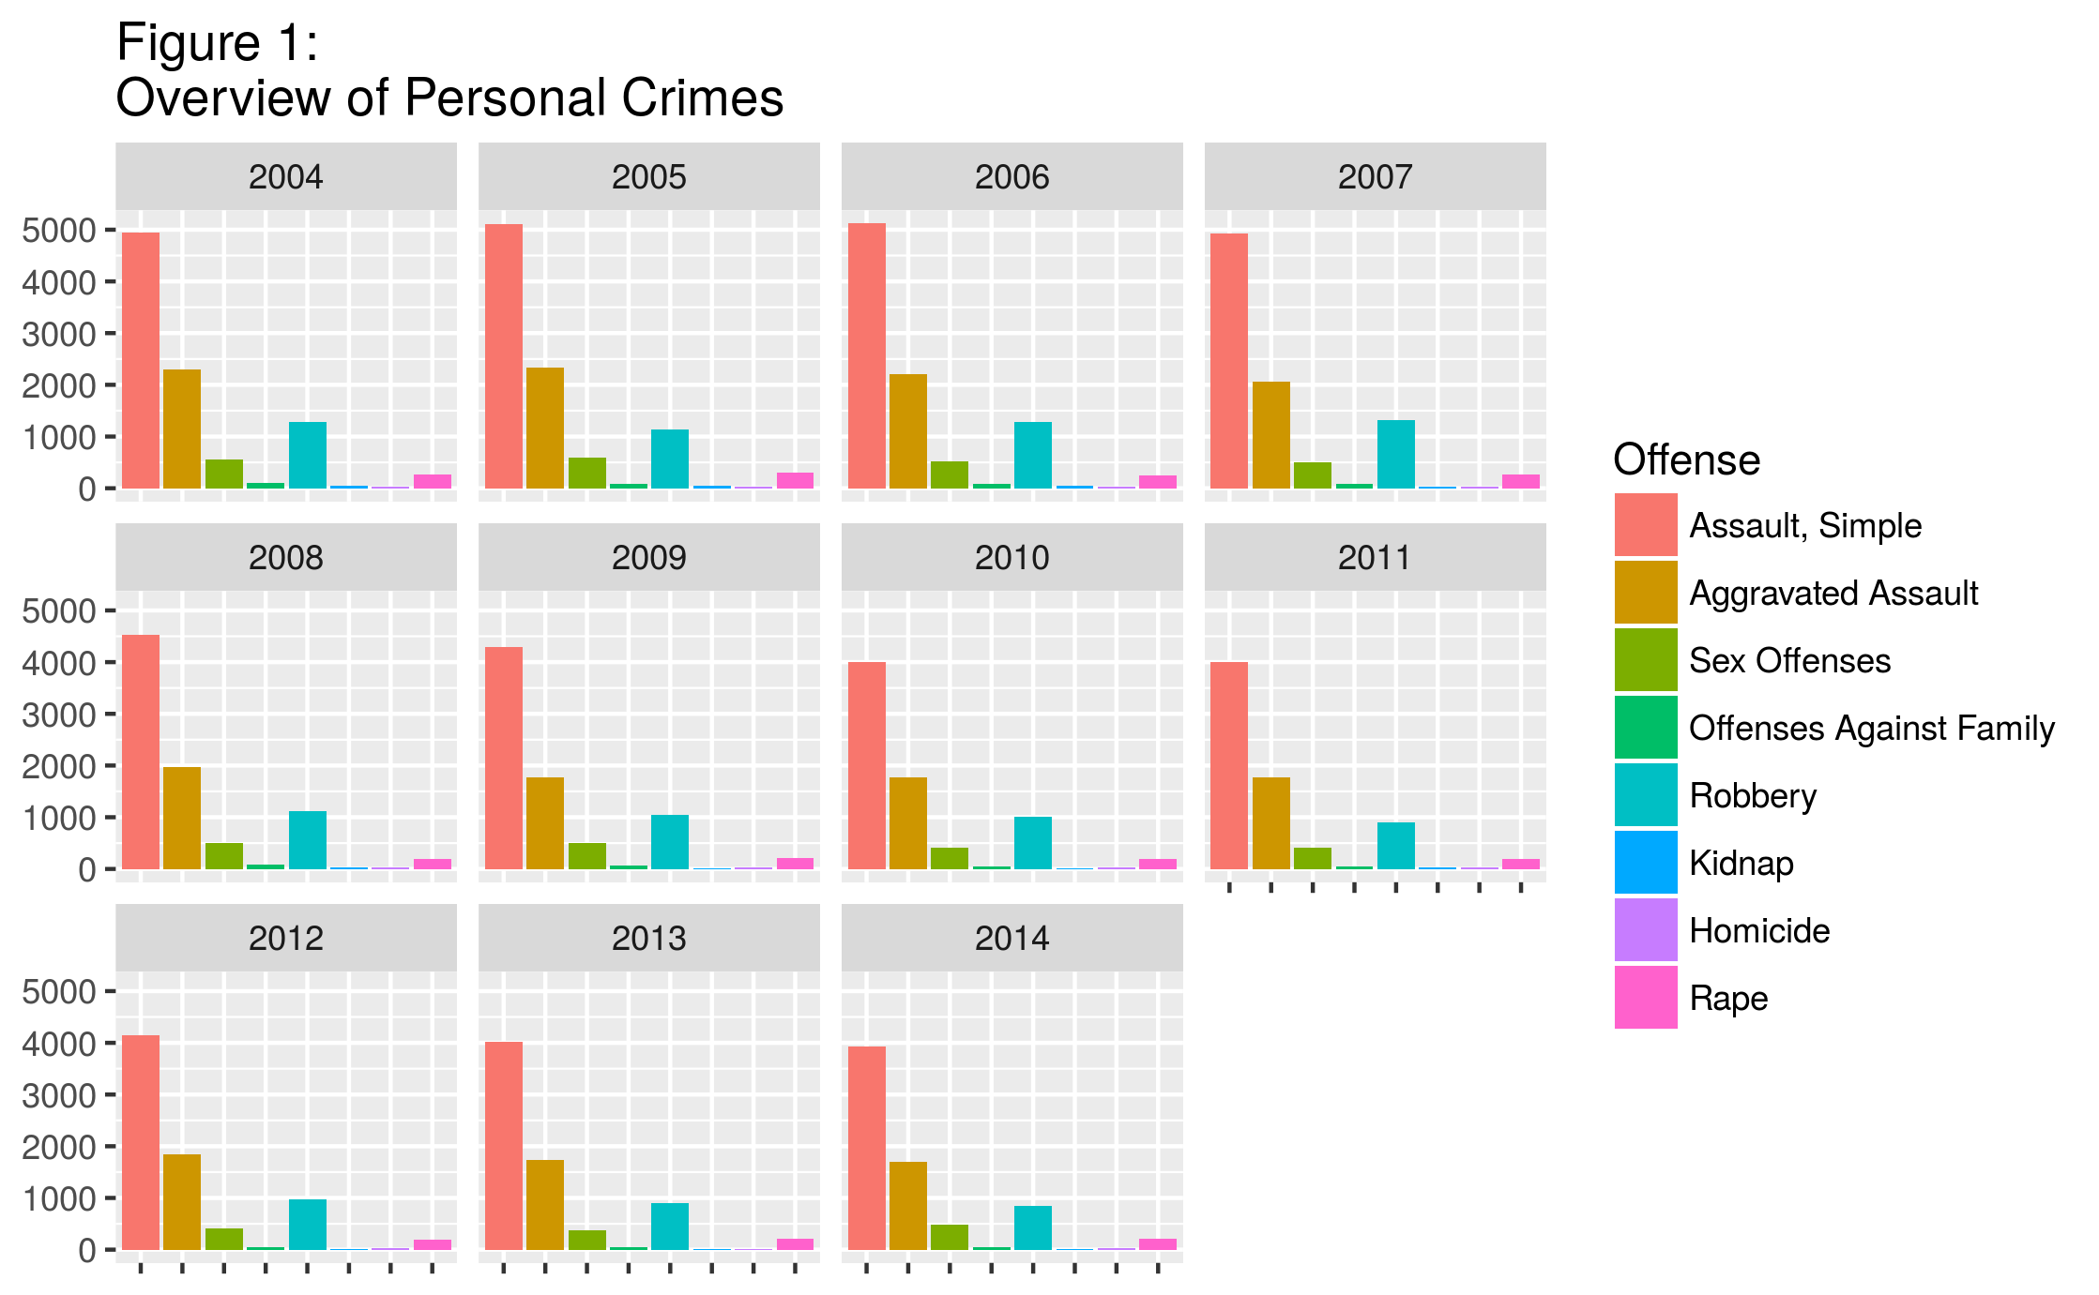

A second bar chart (Figure 2), with the three most frequent crimes removed, is shown next. Again, it appears that personal crimes on this chart are either declining over time, or remaining at a fairly constant level. Of particular interest is the very low number of homicides across the timespan in question: Portland’s relatively low homicide rate has sparked interesting speculation.[6] More discussion on this topic will come later in the paper.

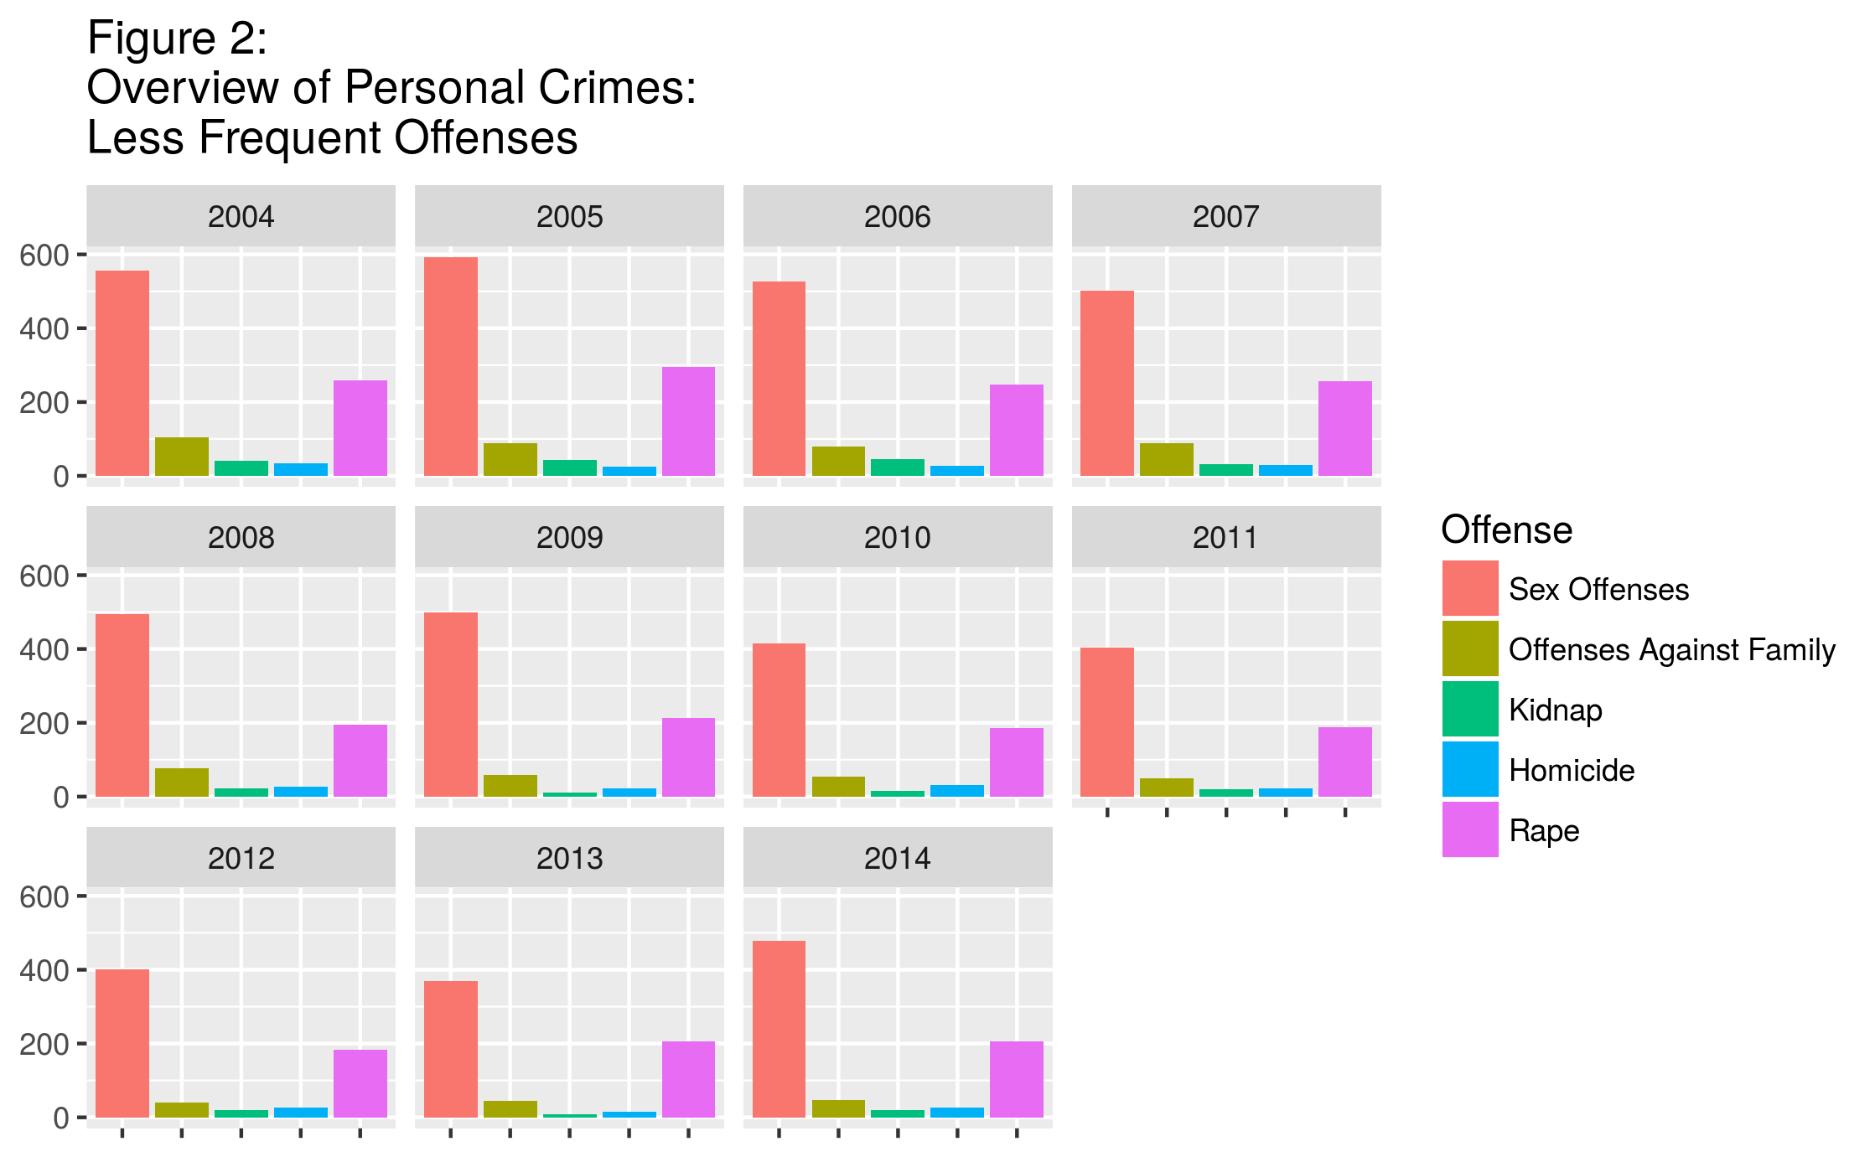

The major trends among these personal offenses are made more clear in several time-series plots. In Figure 3 each offense is plotted on the same graph, with the trends discussed above illustrated. In particular, Simple Assault, Aggravated Assault, and Robbery have decreased by 20.5%, 25.9%, and 33.9%, respectively.

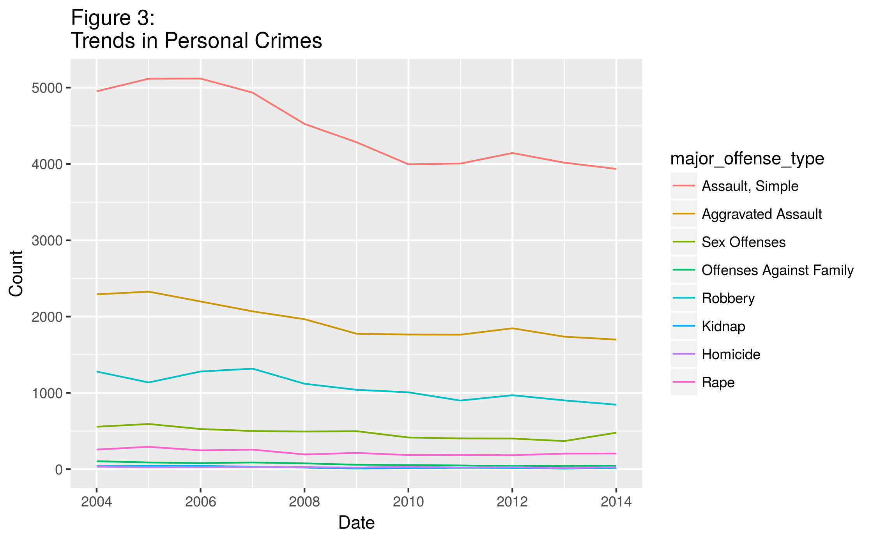

As an illustration of the inappropriate nature of mathematical modeling of the data in question, a linear regression model was constructed for the Robbery offense. Figure 4 shows the scatter plot of Robbery offenses per year for the time period 2004 – 2014, with the regression line included. The linear model fits fairly closely for the later years in the window, and not as well for the earlier years. Similar difficulties were encountered with many of the offenses under scrutiny in the project, leading to the conclusion that a linear regression is not the most appropriate model for describing the occurrence of criminal offenses in this case. Exploring more complex models is beyond the scope of this project, but could be the subject of further inquiry (perhaps for the duration of several careers).

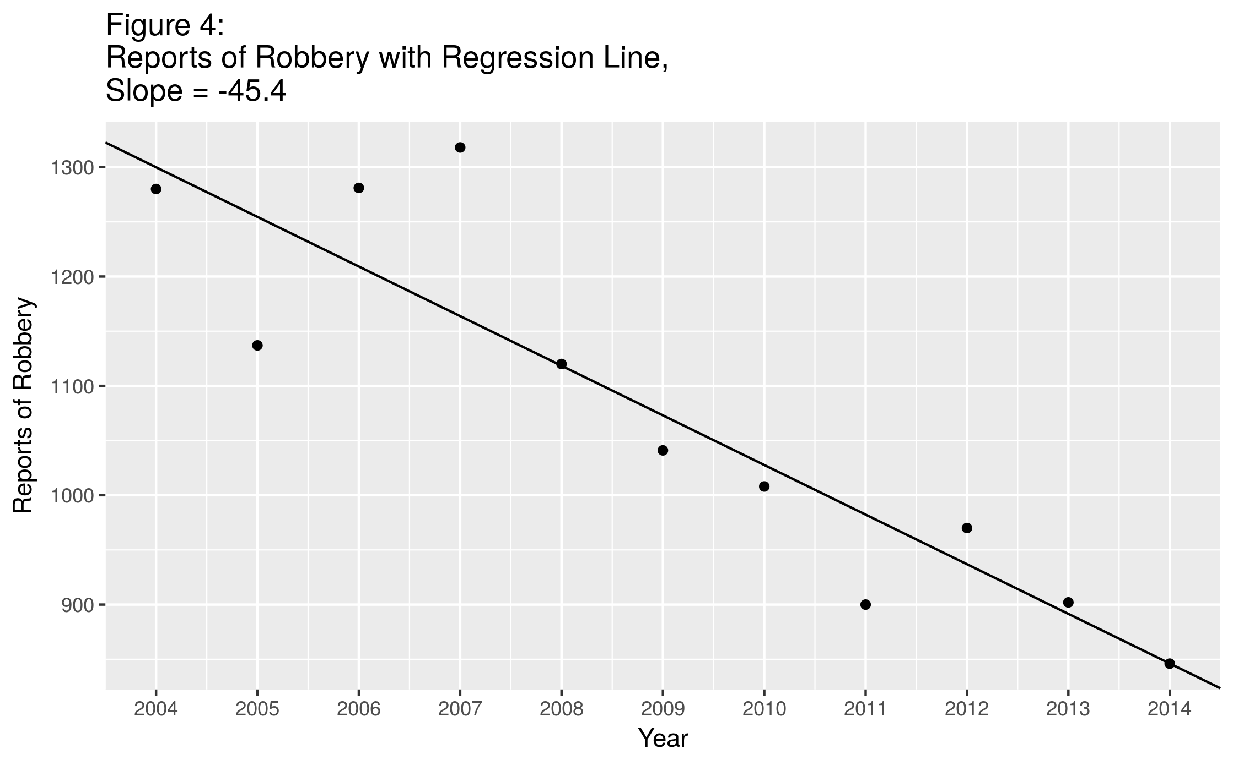

Returning to personal crimes in general, when we remove the three most frequently committed offenses from the line graph, we can see trends in the remaining offenses more clearly (Figure 5). In particular, using the same elementary method of finding the percentage change from 2004 to 2014, we see that several offenses have seen marked decreases: Offenses Against Family and Kidnapping have decreased 56.2% and 50%, respectively, while Homicide and Rape have decreased 18.2% and 20%. Sex Offenses have also decreased 14%, despite the upward spike visible in 2014.

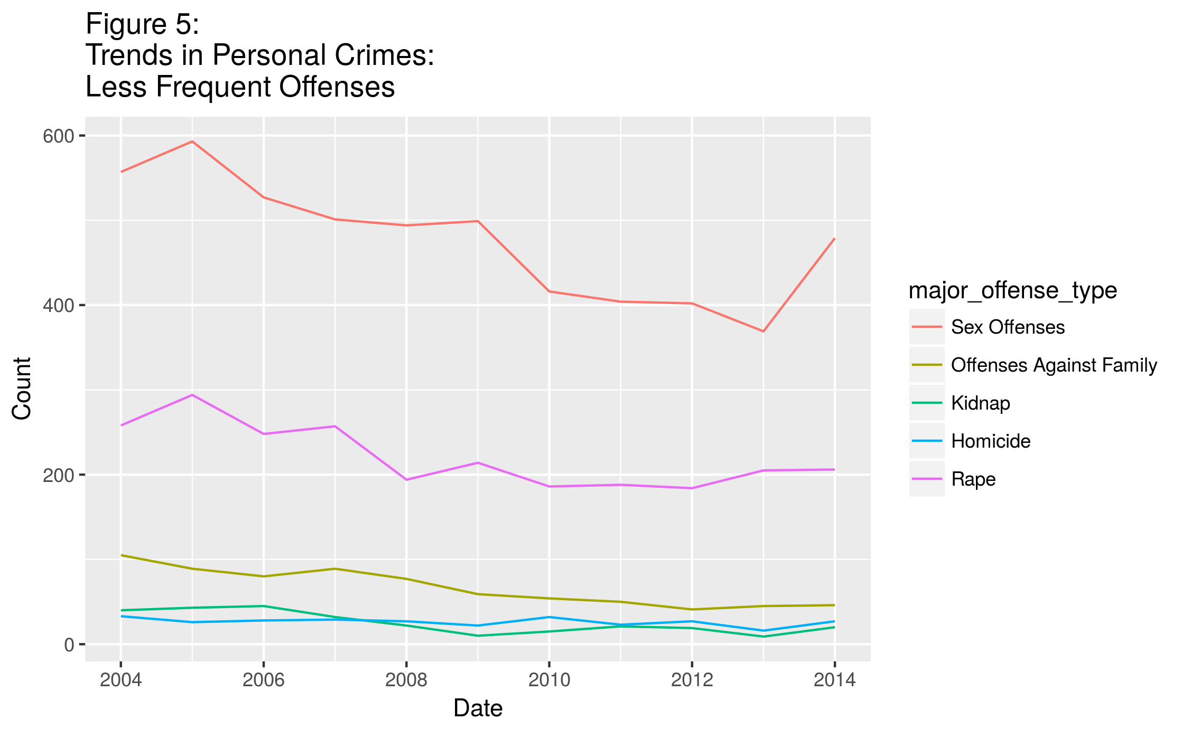

A series of charts and graphs similar to those discussed above follows, this time examining property crimes. One observation that can be made at the outset (Figure 6) is that Larceny accounts for a large percentage of crimes in this category. This isn’t too surprising, since larceny includes such minor offenses as shoplifting and pickpocketing, and the value of such items can be relatively small. In fact, larceny accounts for about 33.7% of all crime, total, in Portland for the time period, and 49.6% of property crime.

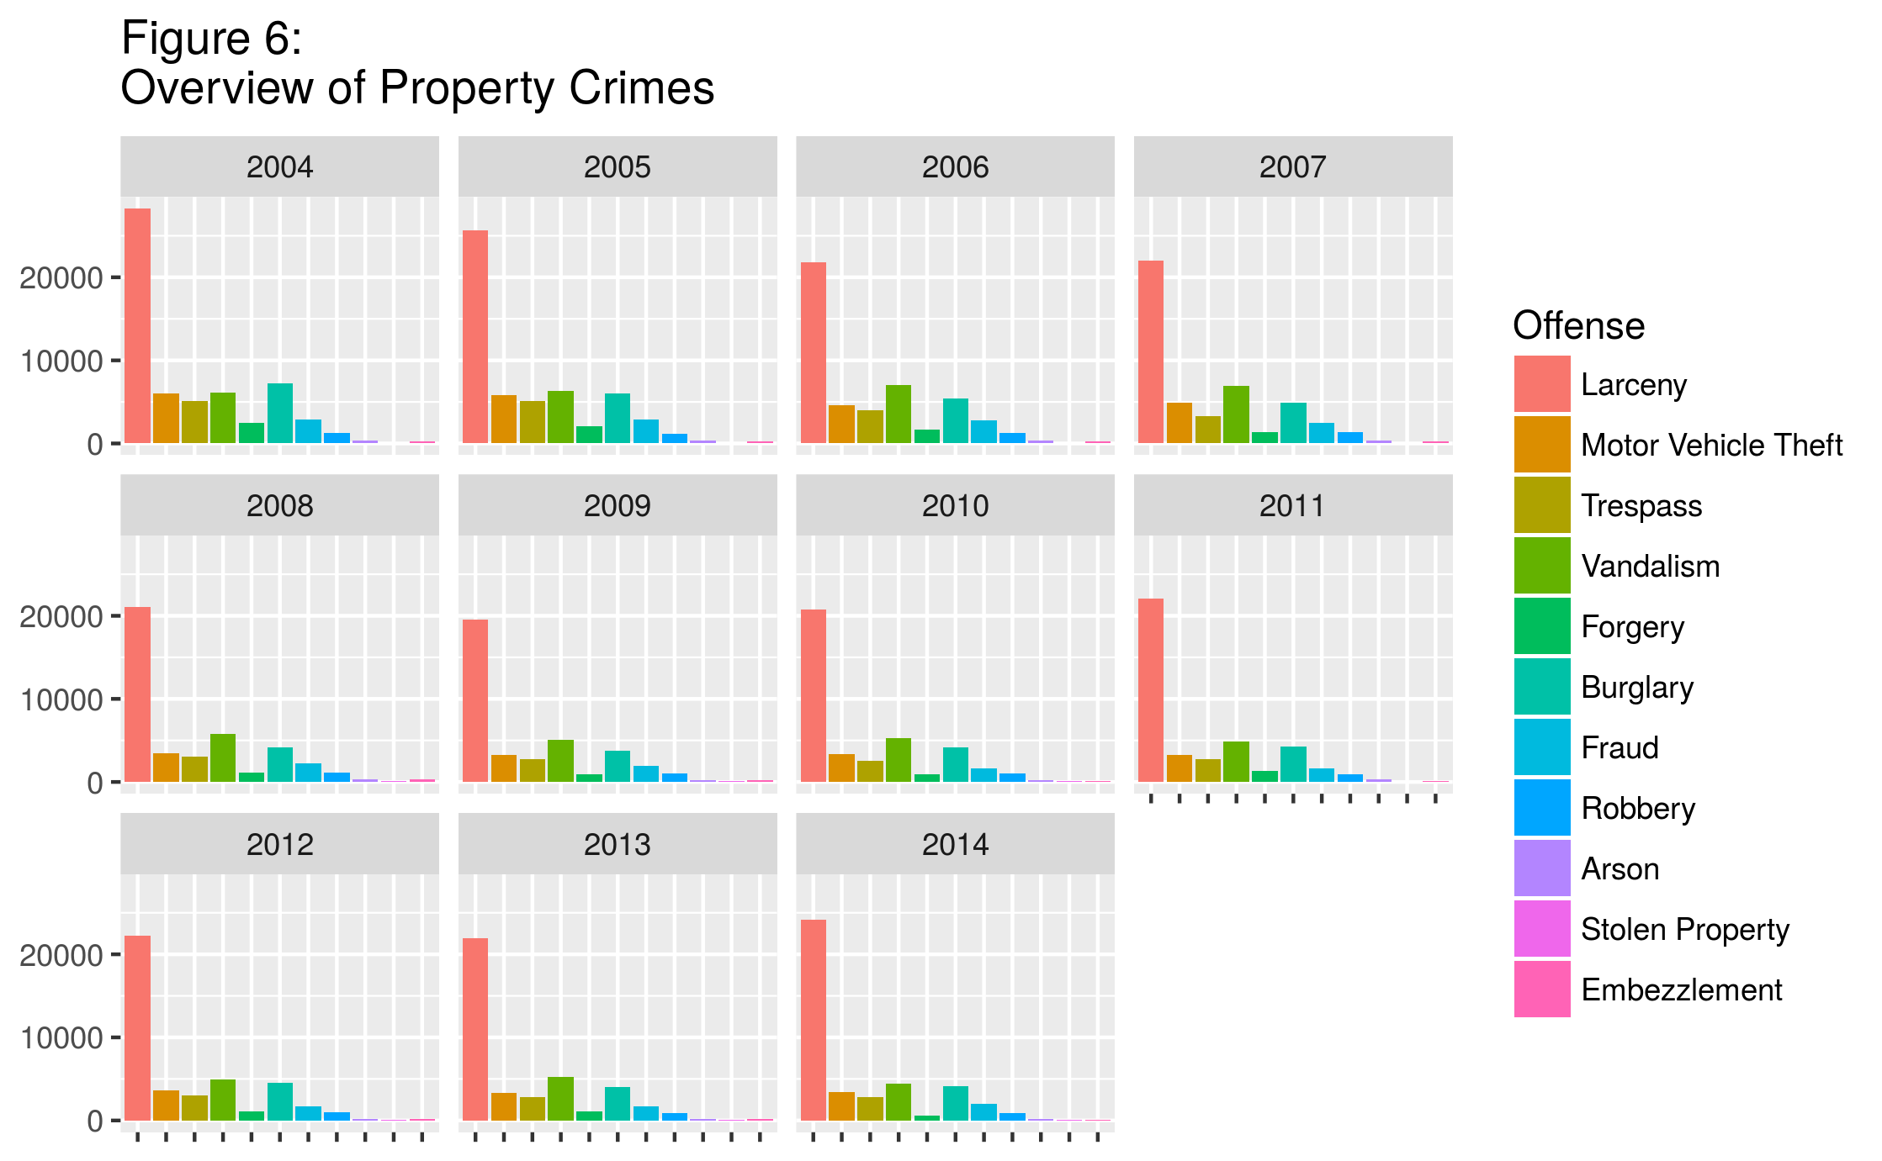

Inspecting the property crimes without Larceny included in the bar graph (Figure 7) reveals the relative frequency of the remaining offenses. It is interesting to note that so-called “white-collar crimes” such as Fraud, Forgery and Embezzlement have low levels relative to “street crimes” such as Motor Vehicle Theft, Trespass, and Vandalism. Although trends for each offense type are somewhat apparent in the charts above, line charts are again provided to make these trends more visible.

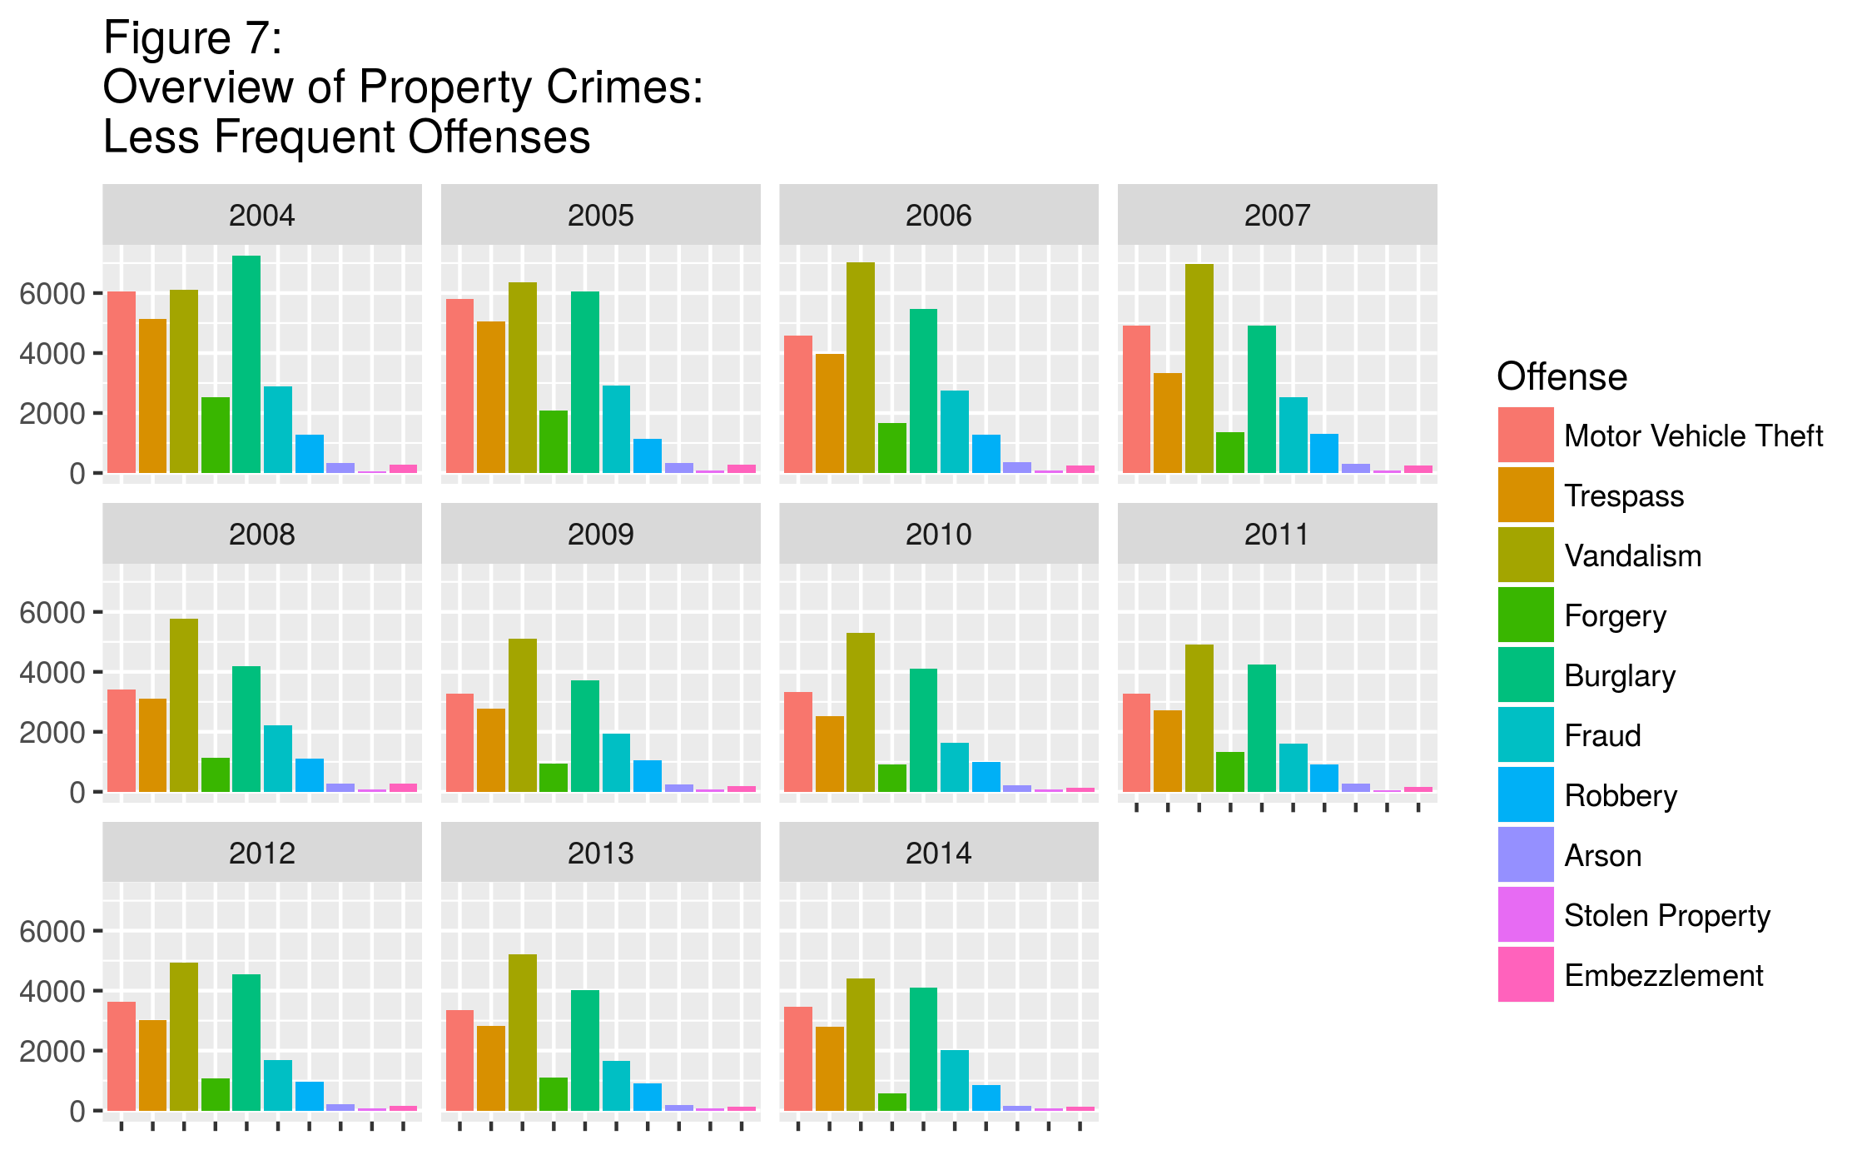

Larceny is seen in Figure 8 to be on a general downward trend until 2009, then the rates tend to increase again, though at a lower rate than they had been decreasing previously. Despite this increase, from 2004 to 2014 the total percentage decrease was 14.4%.

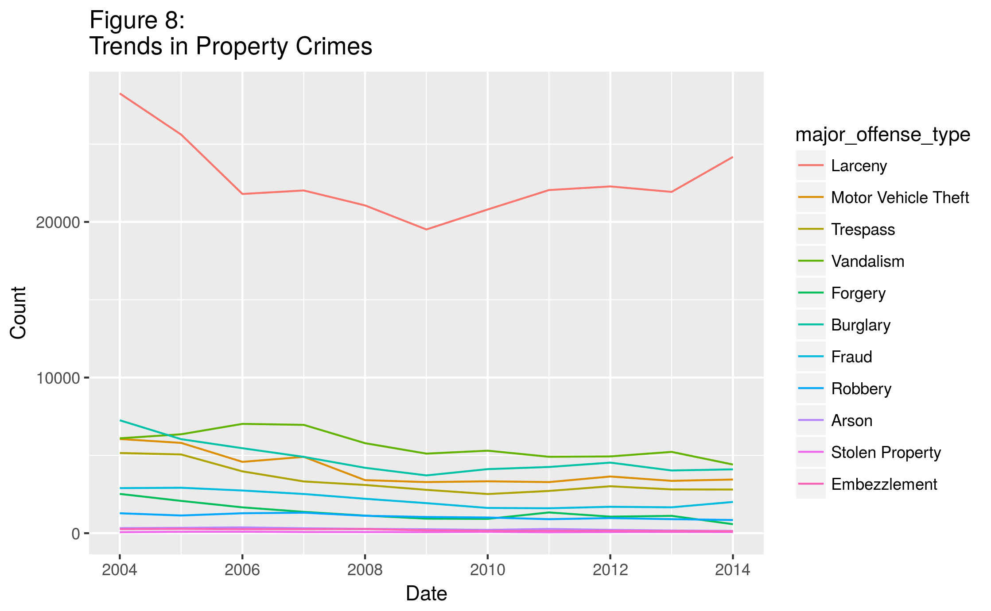

With Larceny removed from the line graph, the downward trend of each of the remaining offenses is quite apparent (Figure 9). In particular, reports of the “white-collar crimes” Forgery, Fraud, and Embezzlement, have decreased 77.1%, 30.7%, and 52.5%, respectively, while other crimes have decreased a comparable amount. The exception to this is the “(Possession of) Stolen Property” category, which is the only one in this category that actually saw an increase over the time period, from 63 incidents in 2004 to 72 in 2014, a change of +14.3%.

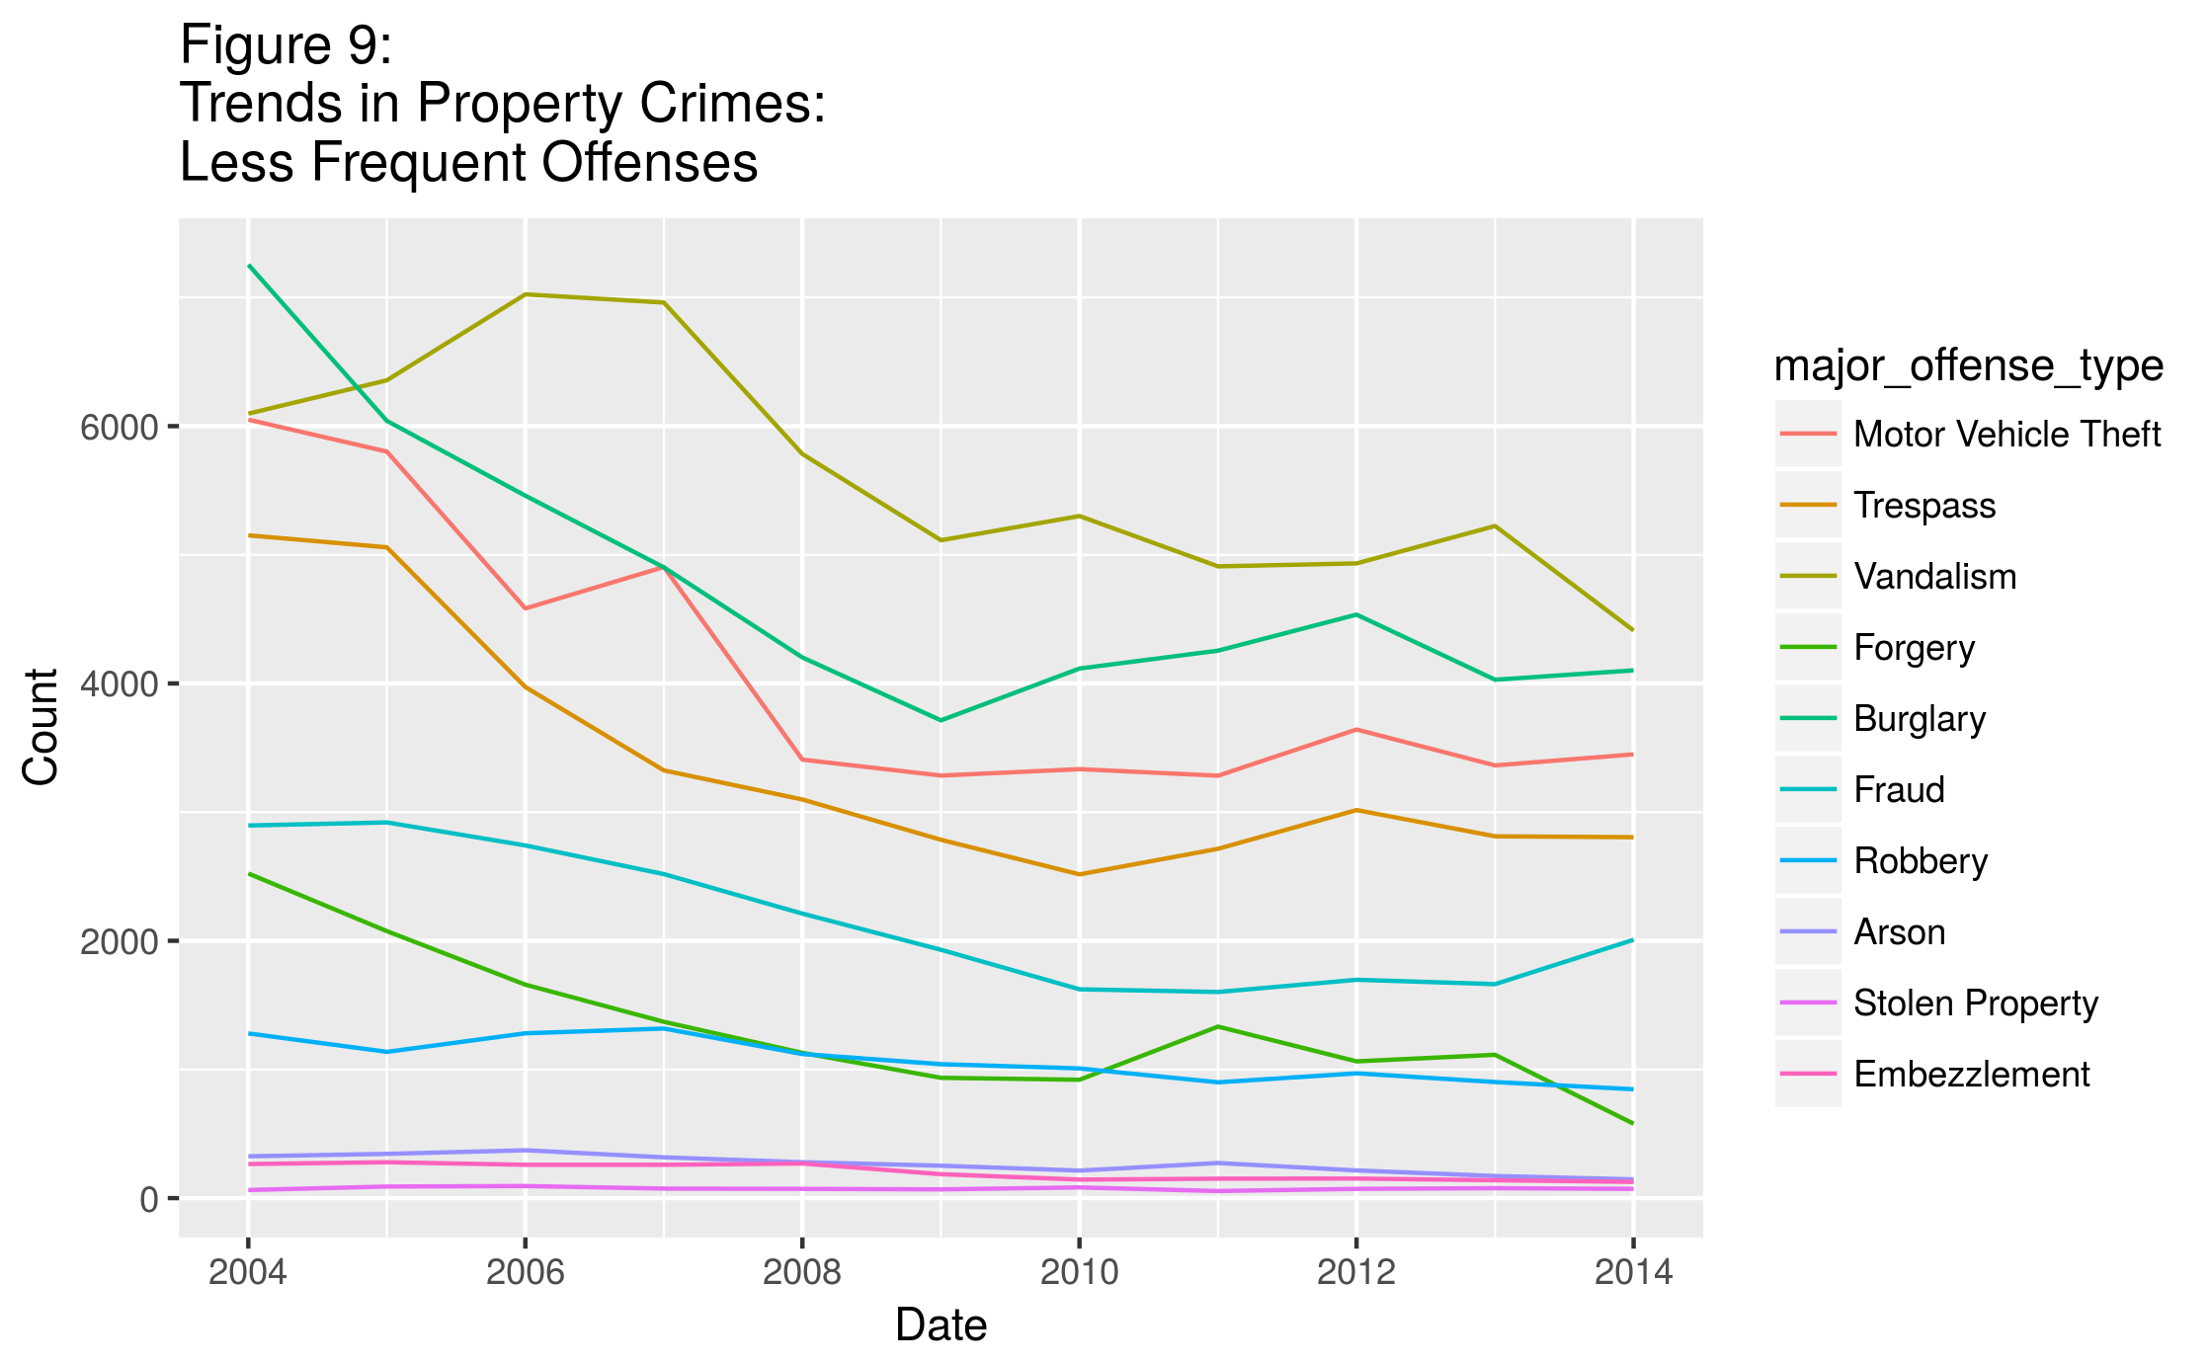

The statutory crimes under examination are shown in Figure 10. For this data set, the crimes of lower frequency include Weapons, Curfew, Prostitution, and Gambling. Among these data are those that do not necessarily involve damage to a person or their property; the levels relative to each other appear to have remained fairly constant over the course of this time period, except for Liquor Laws and Drugs. These two offenses appear to vary more drastically than the other offenses under examination.

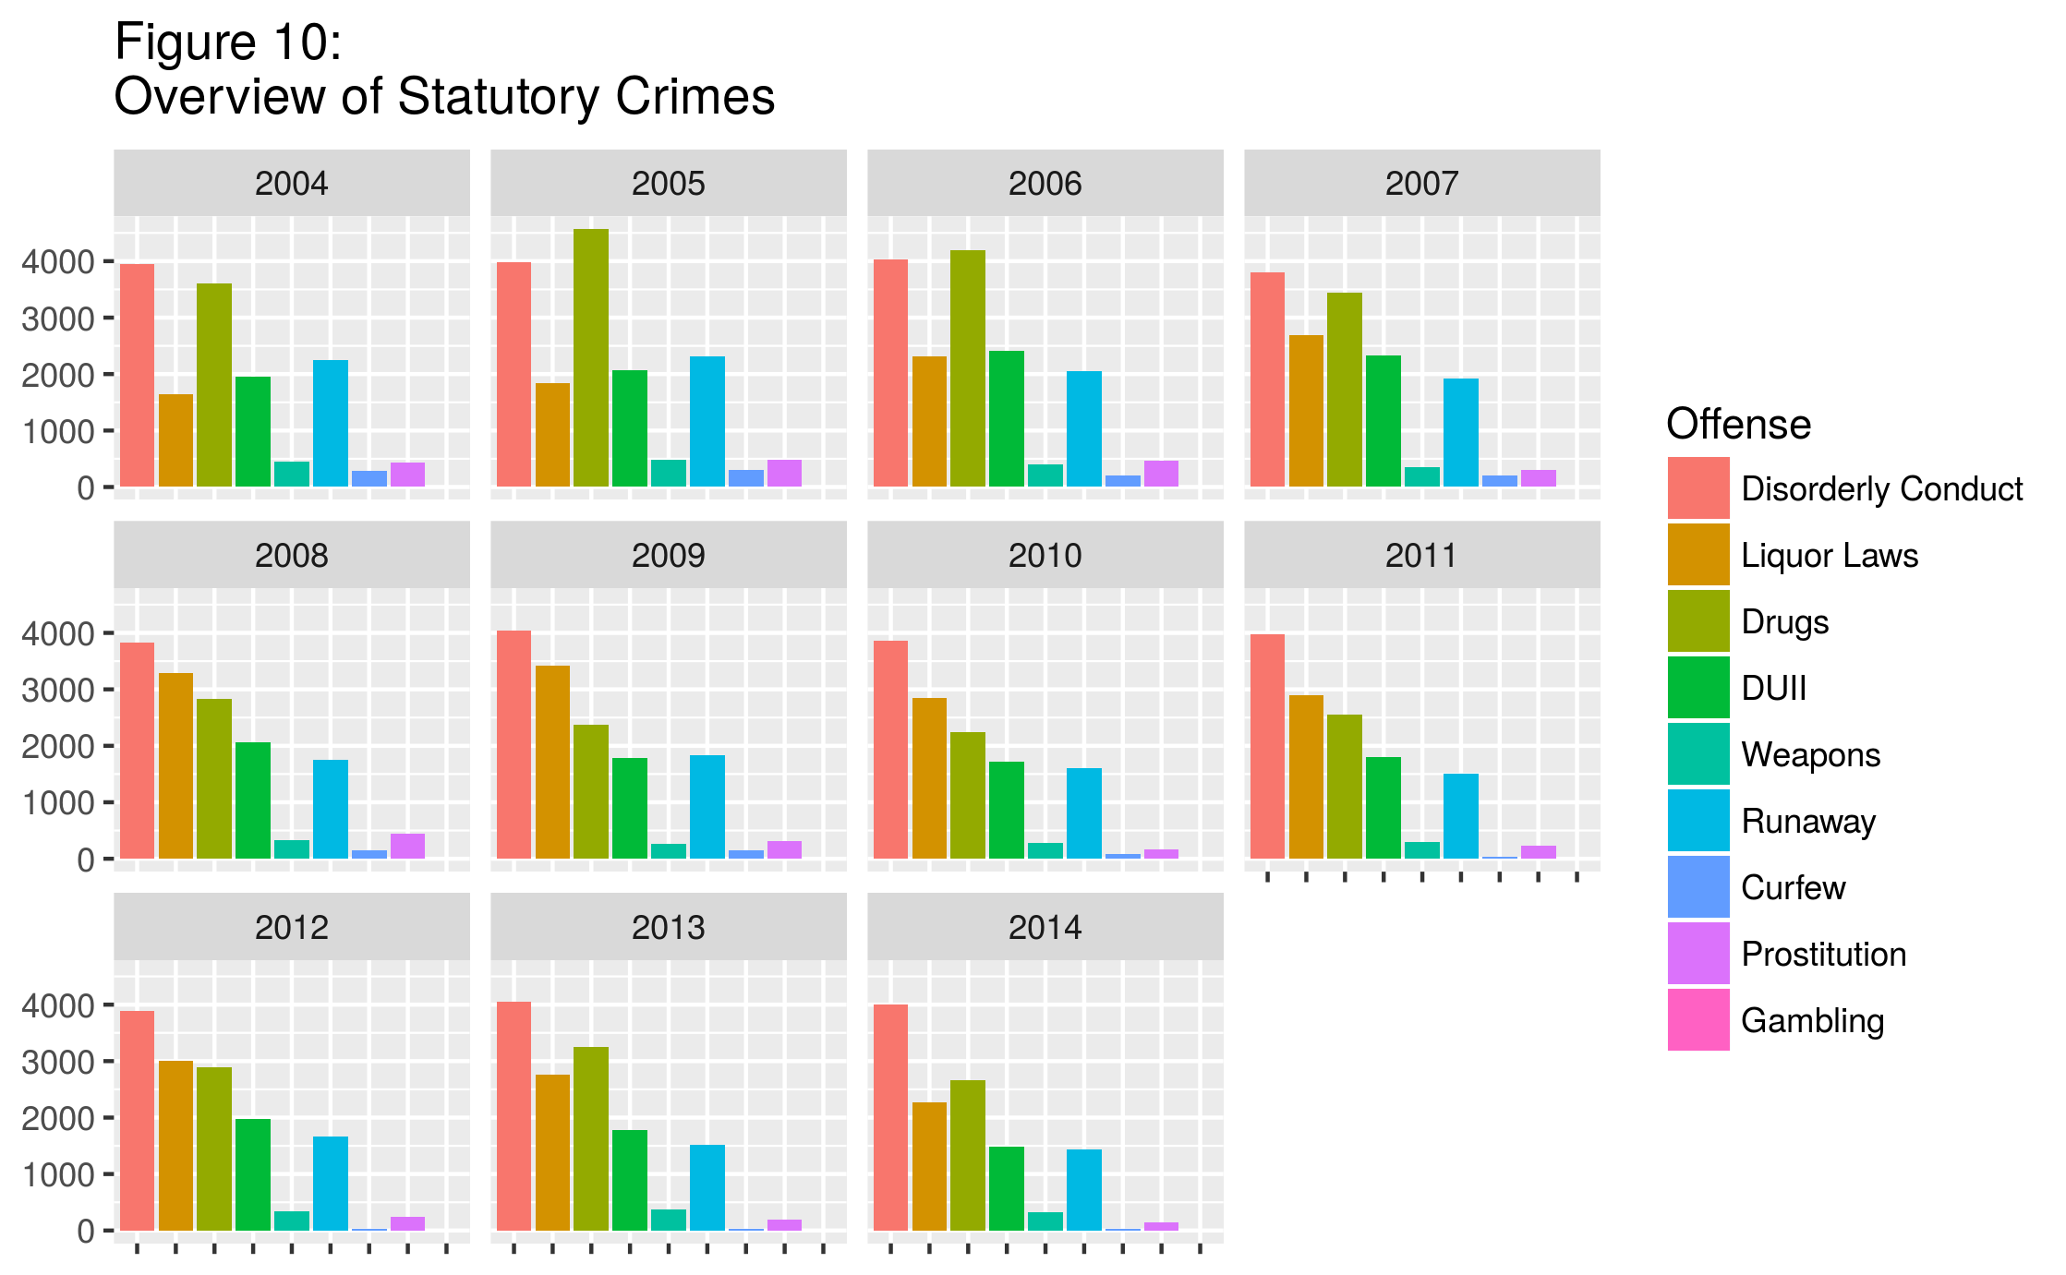

It appears that Liquor Laws and Drugs may have a negative correlation: when one is high, the other is low, and vice-versa. A correlation analysis revealed the correlation coefficient to be -0.707, indicating a moderately strong correlation. This correlation is depicted in Figure 11.

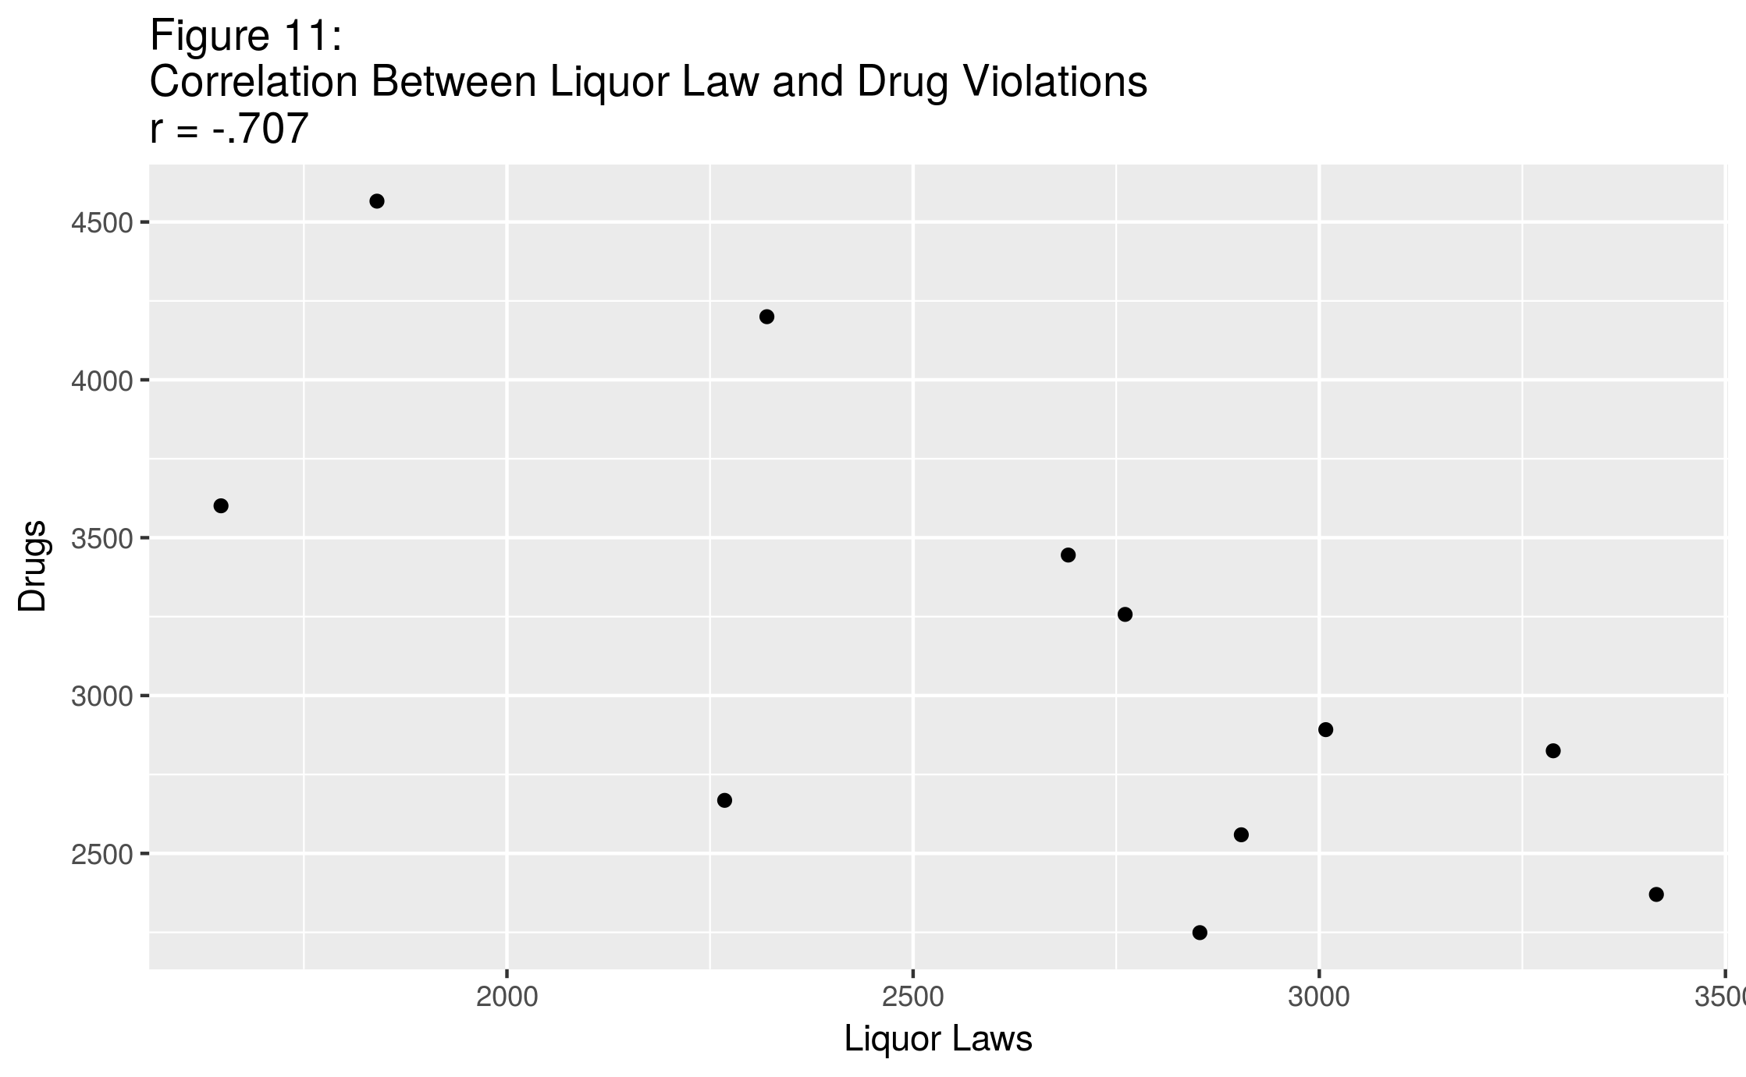 One effect that may come into play in regards to drug-related offenses is Oregon’s legalization of recreational marijuana, which went into effect in July 2015. When new data is released it will be interesting to see whether and how this new statute has an effect on police and criminal activity.

The trends made visible in the line chart shown in Figure 12 seem to indicate that most of the offenses in the statutory crime category have either decreased slightly or maintained a fairly regular level during 2004-2014. The exception is Liquor Law violations, which saw a 37.6% increase during this time period. Drug violations, on the other hand, saw a 25.9% decrease. Given the correlation discussed above, it may be that these two offenses have a cyclical relationship, and that these increases and decreases may be reversed in the future.

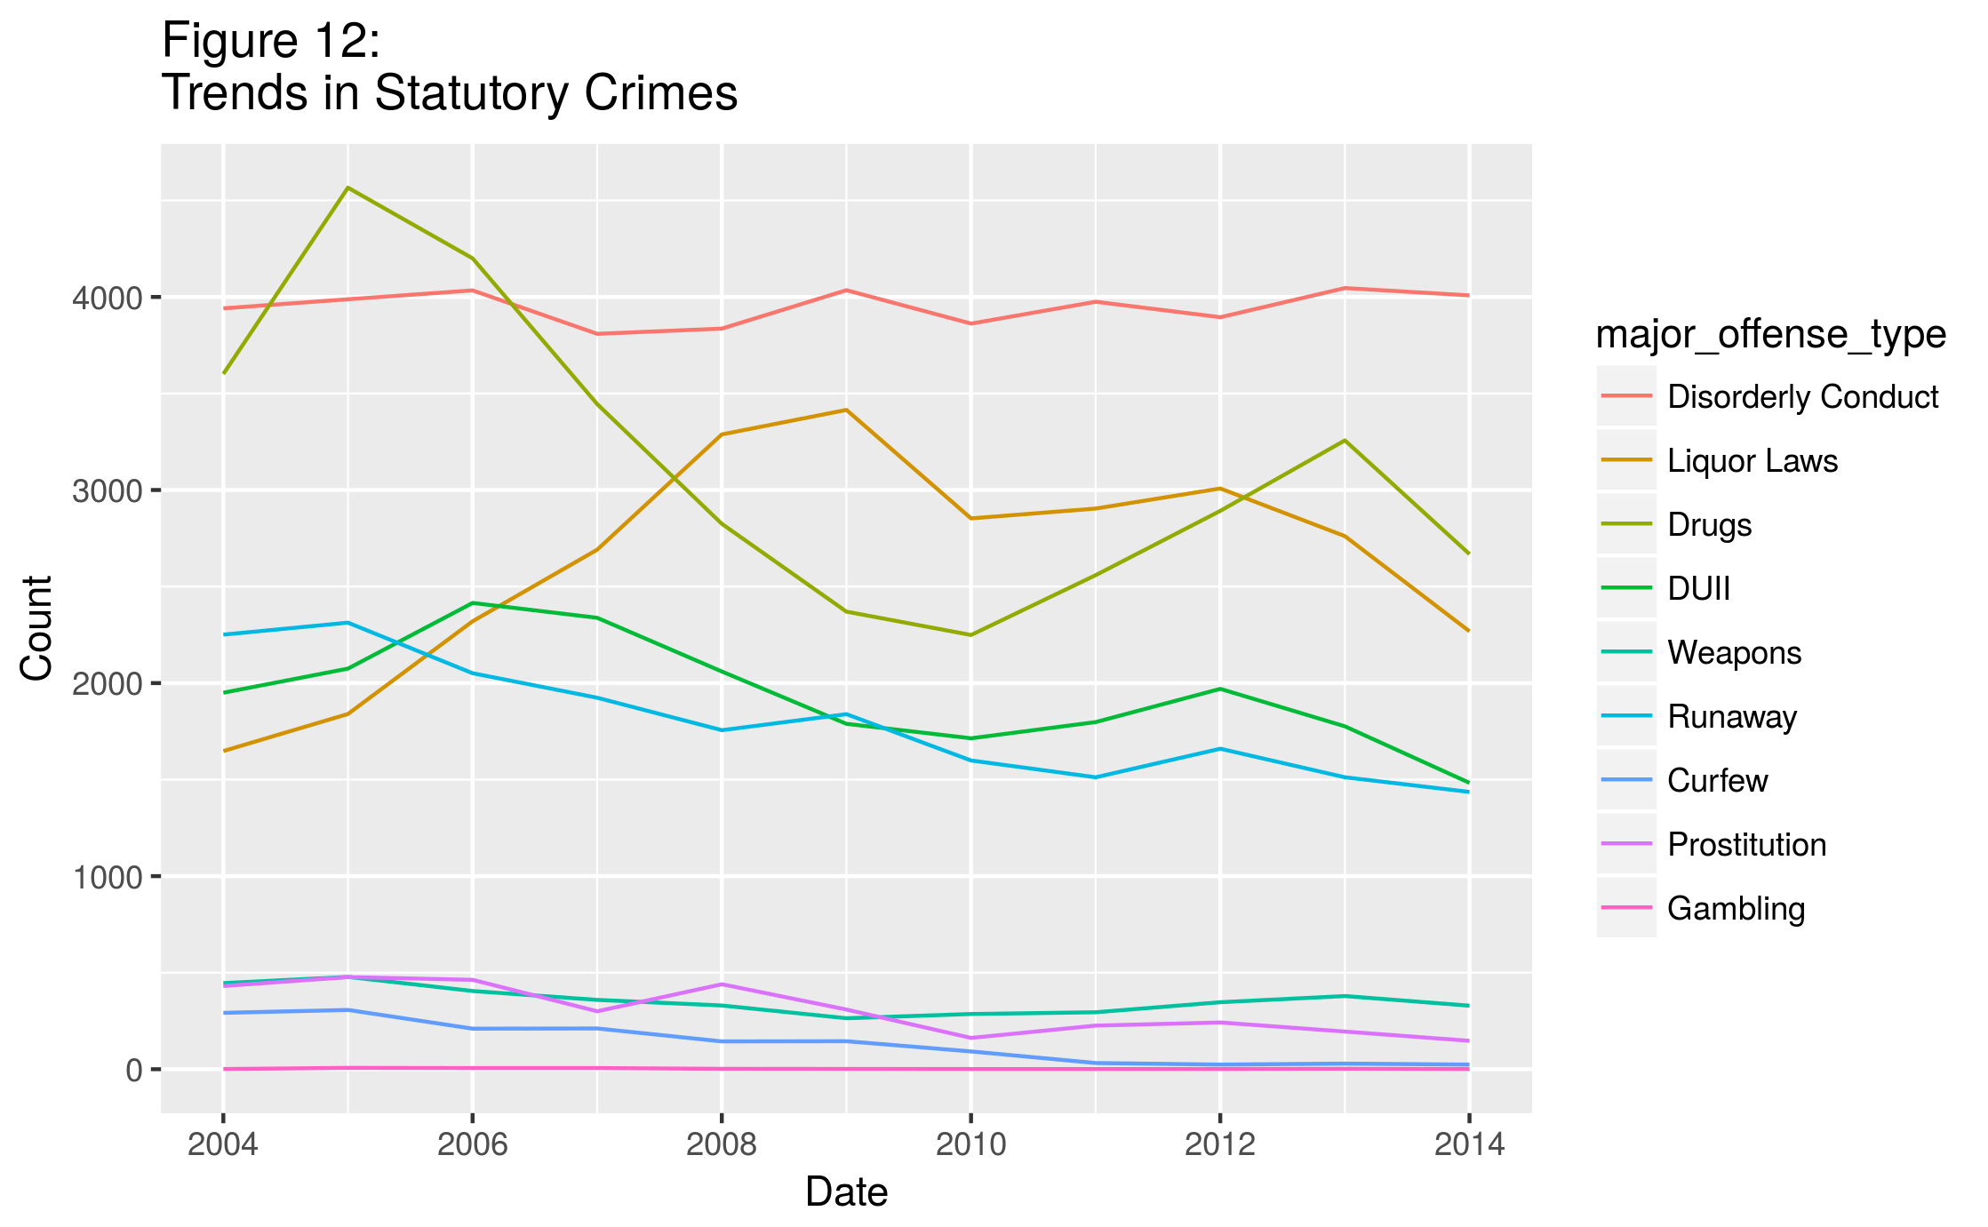Disorderly conduct remained fairly constant at a slight raise of 1.7%, while Gambling had a net change of 0 (the annual number of offenses for gambling had a minimum of 0 in 2009 and a maximum of 7 in 2005). DUII, Weapons, and Prostitution saw decreases of 23.9%, 26.2%, and 65.9%, respectively. Runaway and Curfew saw decreases of 36.2% and 91.8%. The actual Curfew numbers (the most drastic reduction in the dataset) were 292 in 2004 and 24 in 2014.

Points of Interest

A Growing Population.

Like other cities its size in the United States, Portland has seen an influx of new people looking for work and opportunity in the past several decades. During the time period in question, Portland’s population grew an estimated 16.2%, while the total number of reported crimes per year decreased by 25.9%. When the correlation coefficient was calculated, it was found to be -0.799, indicating a strong correlation (see the scatter plot in Figure 13).

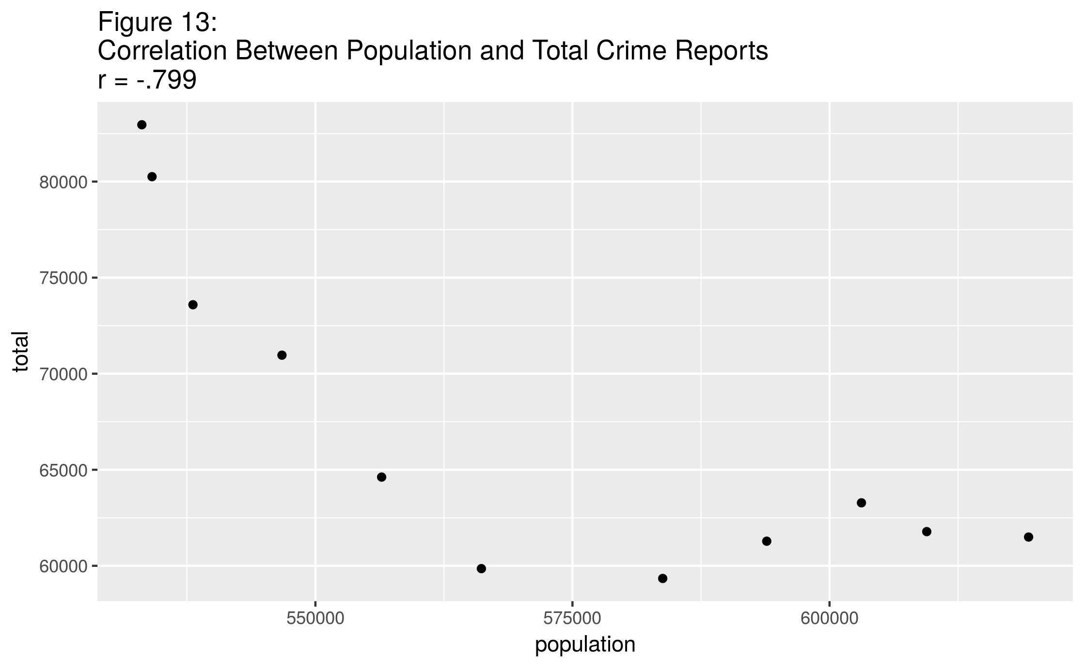

The correlation noted above is between the population and the total incidence of crime in the city. Similar correlations were found between population and individual offenses. The highest correlations (above 0.9) were found in curfew violations, embezzlement, offenses against family, simple assault, arson, runaways, and robbery. This list might indicate that certain offenses are not receiving the same attention from law enforcement that they may have received previously; however, other offenses, such as arson and runaways, would be difficult for law enforcement to deprioritize. This would seem to indicate that a growing population did, in fact, serve to decrease the incidence of some crime (as opposed to police reporting of crime).

Other crimes had a much lower correlation coefficient. Among the lowest were homicide and (possession of) stolen property, both of which had a fairly low incidence rate to begin with.

There are actually two offenses that had positive correlations with population: disorderly conduct (r = 0.184) and liquor law violations (r = 0.392). Neither of these exhibits more than a low-moderate correlation, at best.

**Unemployment.**

Several studies have been done around the issues of criminal motivations, and the various factors that influence changing levels of criminal activity over time. In 2002, Gould, Weinberg and Mustard[7] examined data from the 1980s and 1990s to try to identify correlations between broad economic trends and changing crime rates. They found that when economic markers were good (low unemployment, higher relative wages), certain criminal activity rates did decrease. In particular, the authors argued that young unskilled men (who commit most higher-visibility crime), were more likely to commit property crimes during times of economic difficulty, including difficult job markets. In particular, the unemployment rate and low wages both had a statistically significant effect on the crime rate, with unemployment having the less significant effect of the two. This points to the possibility that some crime is largely motivated by economic forces. This possibility is further strengthened by the fact that changes in the economic climate did not have a statistically significant effect on rates for personal crimes such as murder and rape, which are seldom committed with an economic motive.

Nationally, the unemployment rate hit a high point at 10.0% in October 2009.[8] Portland’s unemployment rate was above 10% from February 2009 through August 2010, with high points of 11.4% in June 2009 and January 2010. It is interesting to note that an increase in Larceny offenses appears to coincide with the spike in Portland’s unemployment rate following the 2007-2009 recession (see Figure 14).

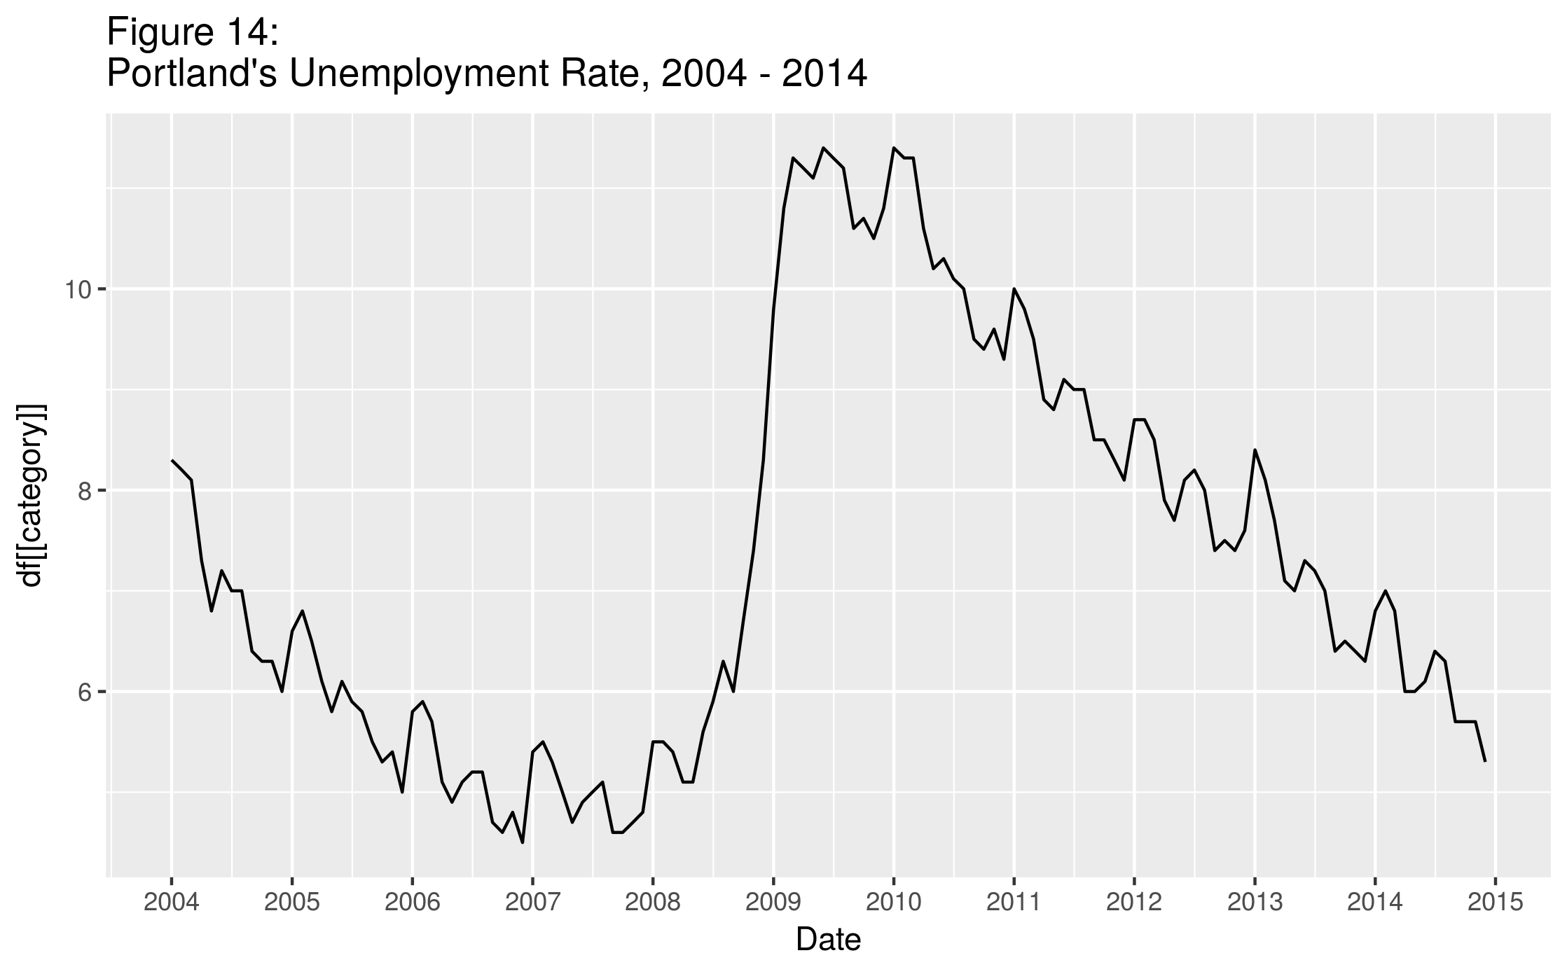

Note that while there was a reveral in the downward trend of larceny offenses reported beginning at this time, no such reveral of trends in personal crimes occurred. This would seem to support Gould’s 2002 finding that higher unemployment may lead to an increase in property crime, but not in crimes without economic motive.

To investigate this further, a correlation analysis was completed. When the correlation between Portland’s unemployment rate and larceny offenses for the time period was calculated, the coefficient was -0.382, indicating at best a low-moderate relationship. Figure 15 shows a scatter plot of unemployment rate vs. larceny reports for 2004 – 2014. As can be seen, a linear relationship is not very apparent between these two variables; thus the low correlation coefficient found above. It would appear that any relationship that is present is actually a negative one: there were actually fewer reports of larceny when the unemployment rate was high.

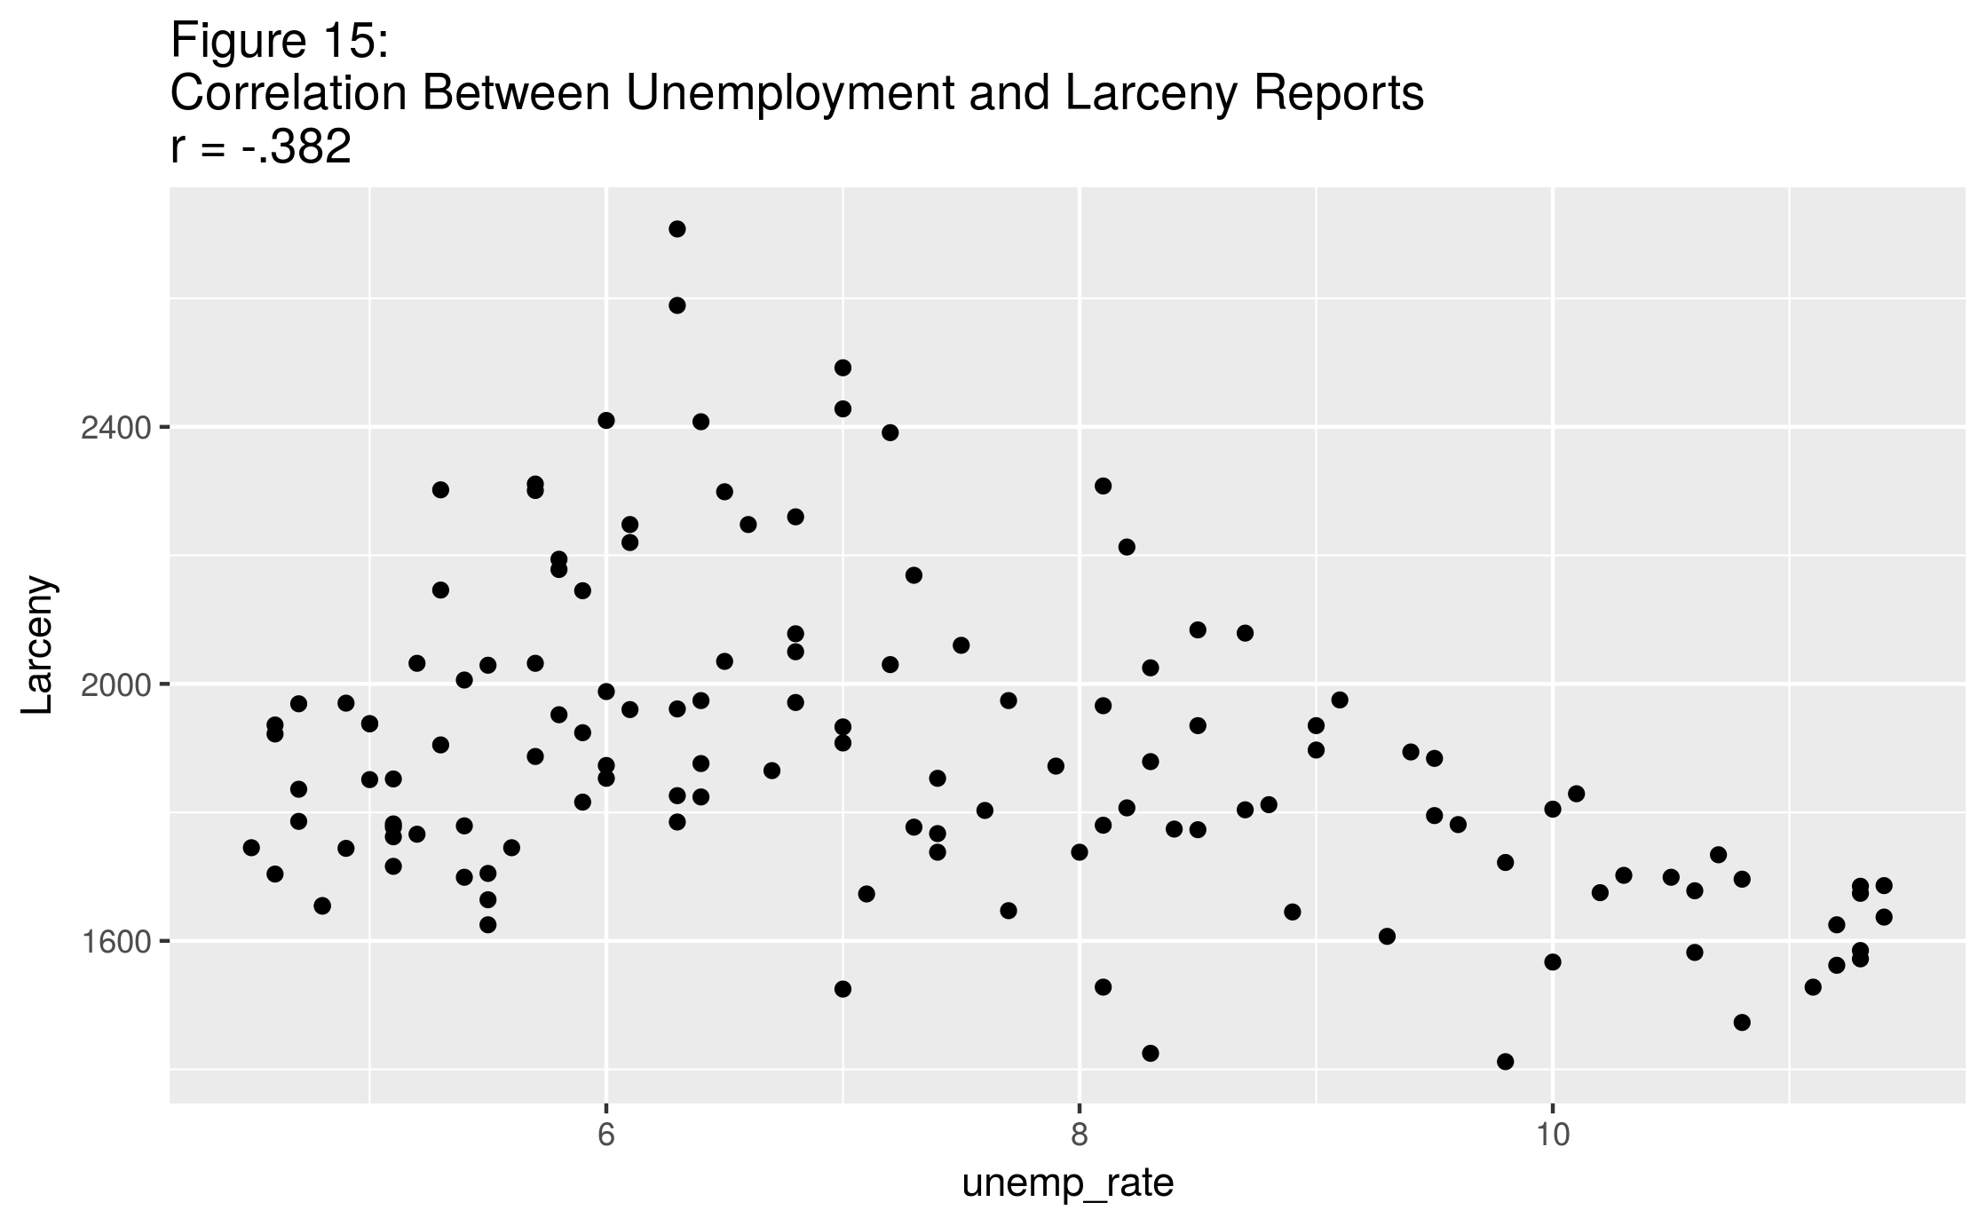

**The “Ferguson Effect.”**

Another question of interest in this report is the effect of certain headline news incidents on crime rates in Portland. In 2016 Pyrooz, Decker, Wolfe and Shjarback conducted an investigation into the so-called “Ferguson Effect,” wherein national crime rates had supposedly increased in the months following the August 9, 2014 “shooting death of an unarmed young black man by a white police officer in Ferguson, Missouri.”[9] The authors of this study concluded that no systematic increase in crime rates had occurred in the months following the death, but indicated that individual cities may have seen some increases in particular crimes, including robbery. Portland did see some moderate increases in certain property crime incidentsin the months following the Ferguson events, however, the month-over-month changes are not unusual and could have been a part of the normal fluctuation in crime rates in the city (see Figure 16).

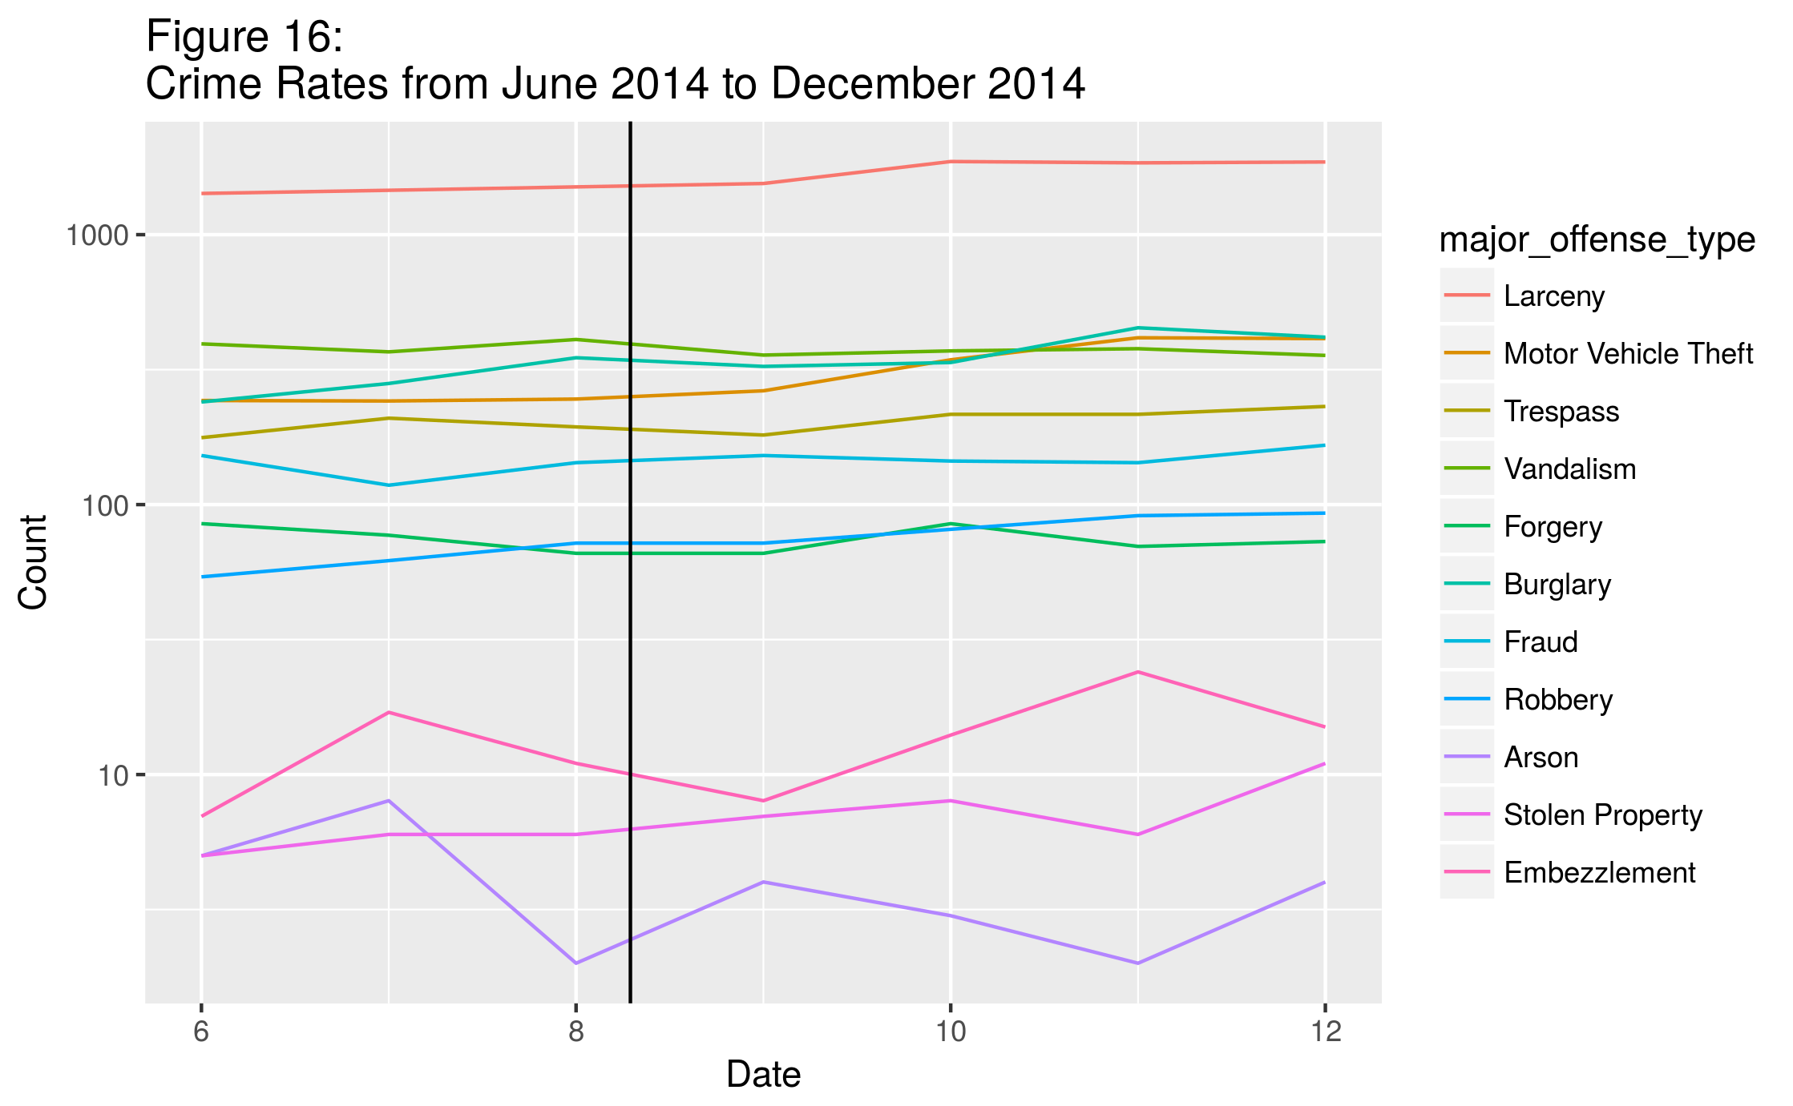

In order to determine whether the event in Ferguson had an effect on the robbery rate in Portland, Student’s t-test was conducted. The null hypothesis was that the events in Ferguson had no effect (the mean value of the crime incidence for each offense did not change). The alternative hypothesis is that the events did, in fact, have an effect on crime in Portland (without specifying whether the effect was to increase the crime rate or to decrease the crime rate: a two-tailed test). The alpha value was set at 0.05.

Since the t-test is best applied to populations that are normally distributed, the Shapiro-Wilk test was used to determine the normality of the count of robberies per day. The result was 0.940, indicating a fairly normal distribution. Figure 17 depicts the frequency distribution for this offense: in fact it does appear to be a somewhat normal distribution, with a slight positive skew.

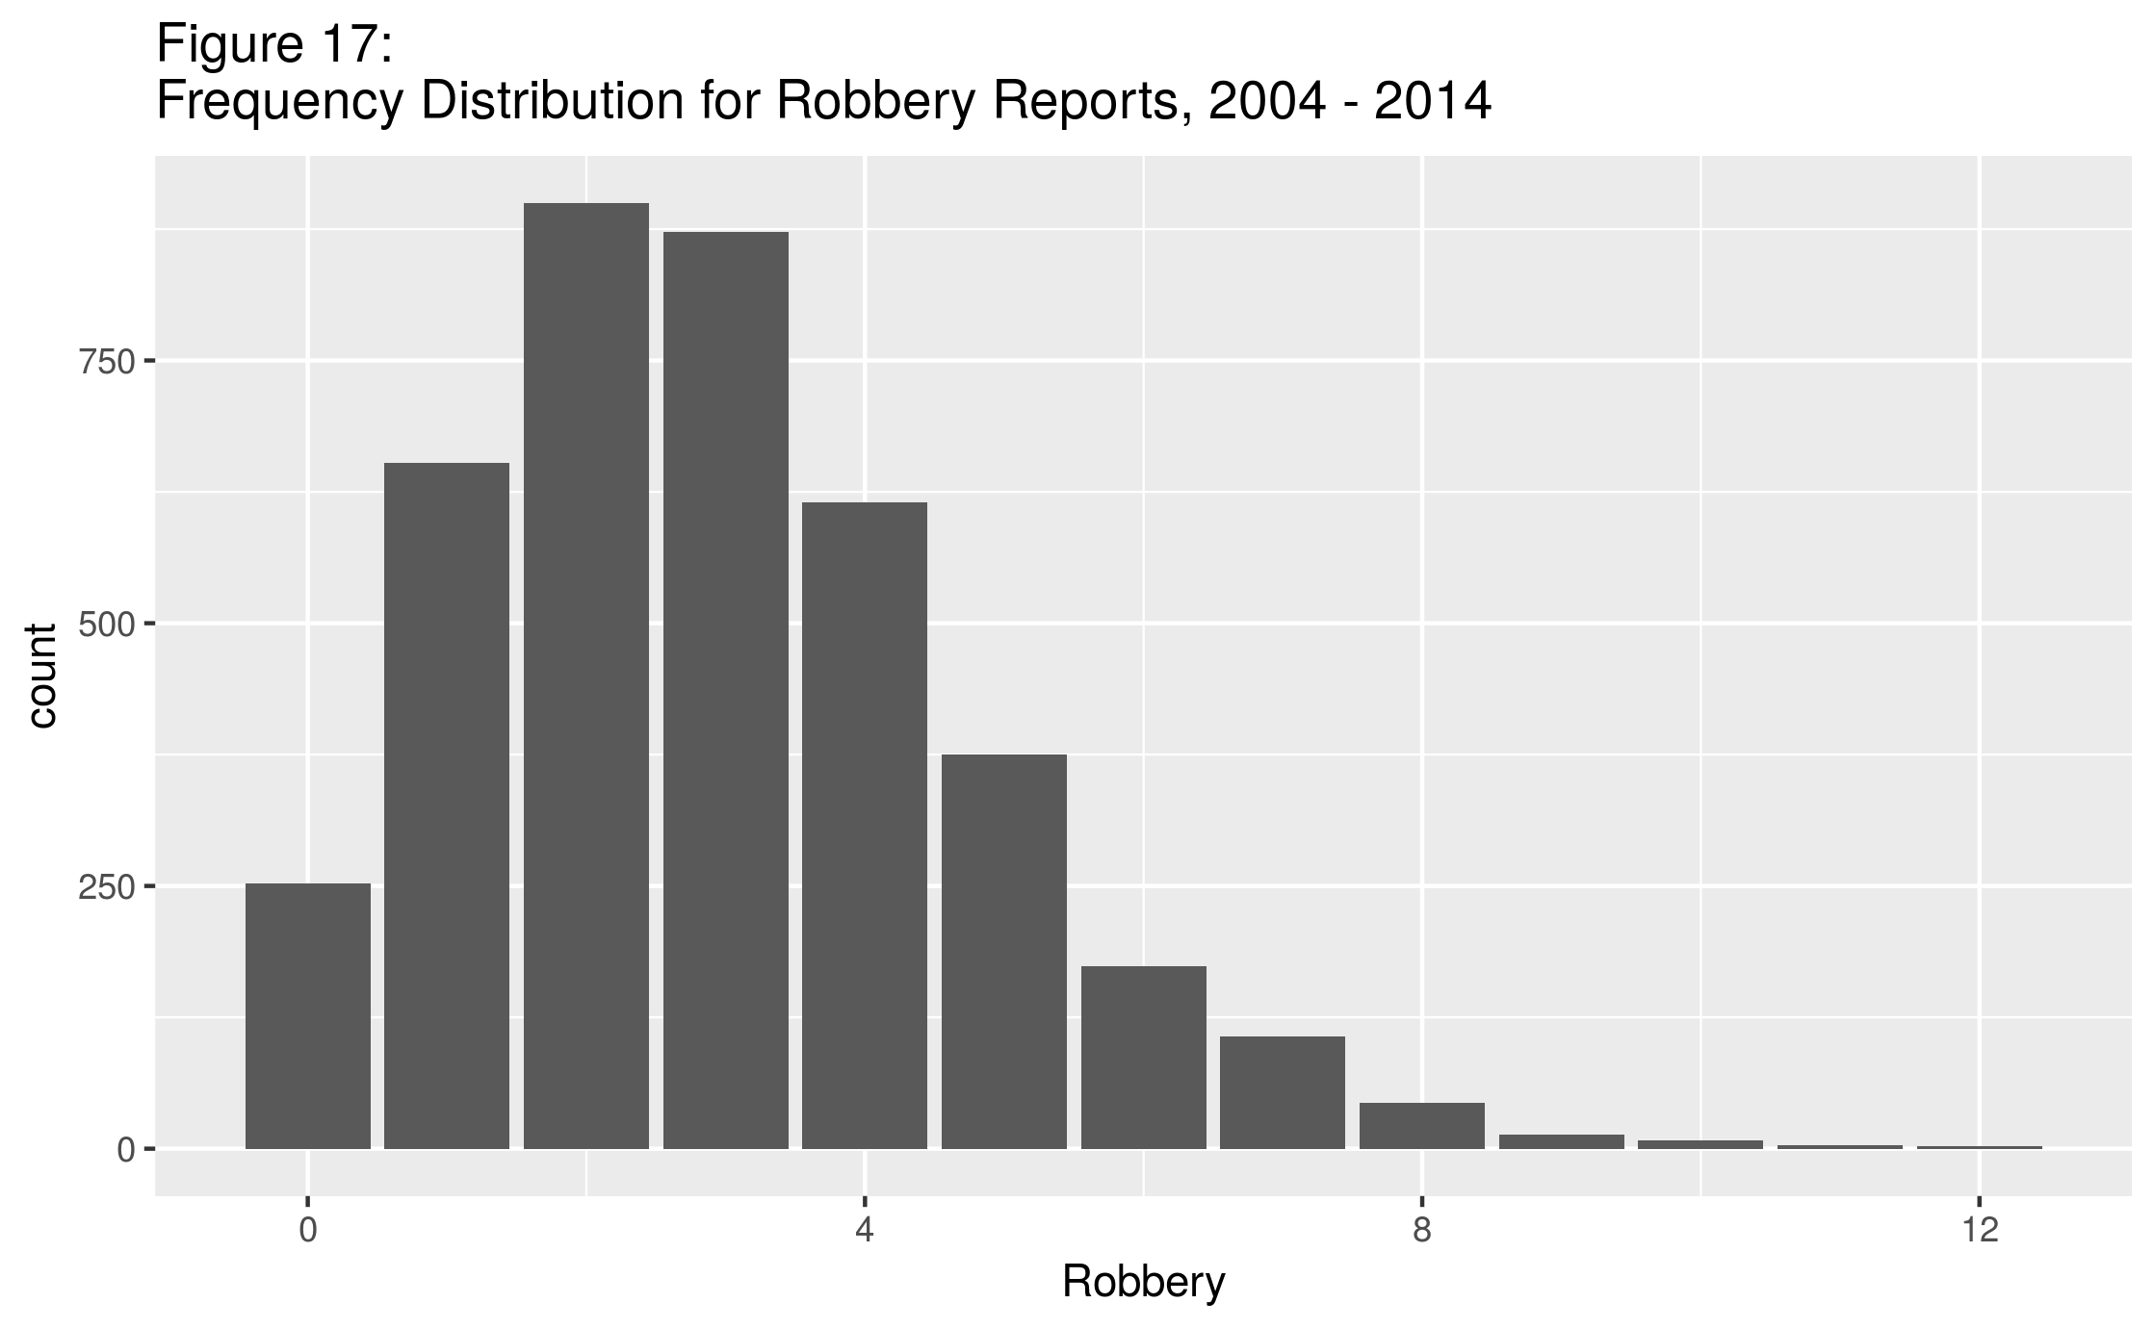

The mean incidence per day for Robbery in 2004 – 2014 was 2.94, with a standard deviation of 1.83, while the mean for the period following the Ferguson events was 2.29, with a standard deviation of 1.65. This gives a t-test score of 4.639, with 157 degrees of freedom. The p-value for the test is 7.3 * 10-6. These values indicate that the means are significantly different, and we accept the alternative hypothesis. It appears that there was a significant effect on robberies in Portland: the mean robberies per day decreased from about 2.94 to 2.29, a 22% reduction. The distribution with the two means indicated is shown in Figure 18.

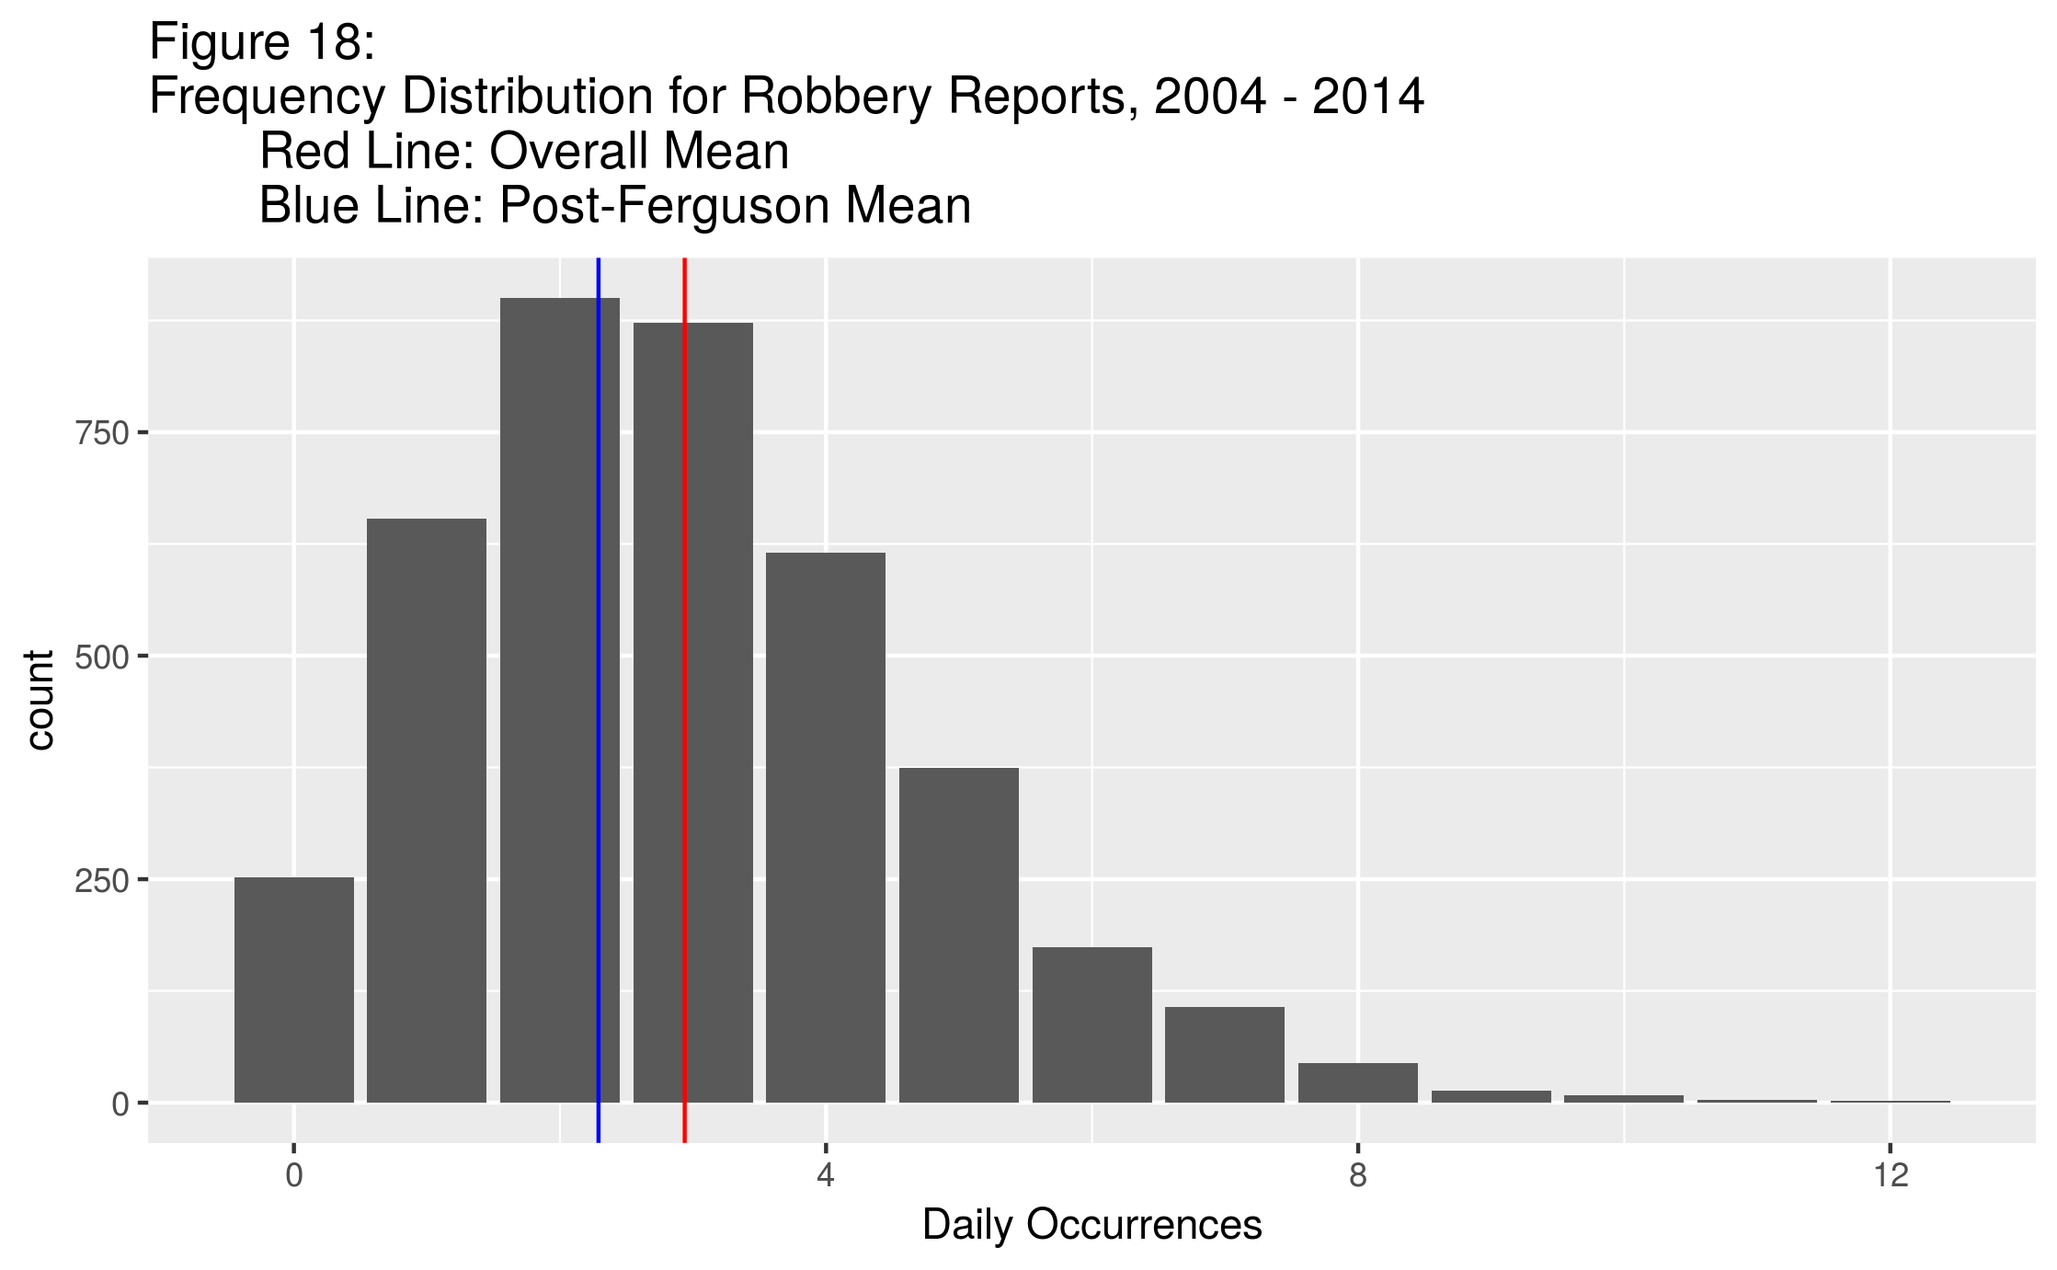

**Relation of Location and Crime.**

It was originally hoped that there might be a way to identify repeat offenders in this data set; however, identifying information has been intentionally removed from the data in the interests of protecting the privacy of individuals. One method that might shed some light on this question, however, is to examine the address of each offense recorded.

The dataset used to create the “Property Crimes” summaries has a total of 502,845 entries over the time period in question, but only 53,605 unique addresses are included in the data. However, it must be noted that several addresses are of the form “12301-12499 block of NE GLISAN ST,” usually includes a number of buildings, especially if there are apartments included in the block. Therefore, this method of determining repeat offenders will probably not be fruitful.

It may be interesting, however, to examine the geographic distribution of the offenses recorded in the data. While identifying information about individual repeat offenders may not be obvious, it may be possible to note patterns in particular areas of the city. A detailed analysis of these incidents and how they relate to the demographics of the city, including economic and other indicators, is beyond the scope of this project, though a limited exploration is attempted. Fascinating reading (of interest to residents of Portland, and to those with an interest in conducting this sort of analysis in general) can be had in the several studies conducted by Meagan Cahill and her associates.[10]

Over the time span in question, PPB recorded nearly 750,000 incidents. Visualizing this volume of data on a map, even when broken into various categories as above, does not lend itself to a clear understanding of the issues involved. Two maps of interest with crime incidents plotted are included below.

Homicide was examined first. Portland has an unusually low homicide rate, compared to other cities in the United State of a comparable size. Peter Korn has written an in-depth article[11] that attempts to illuminate some possible reasons for this low rate. Possible factors that are investigated are poverty, gentrification, problem-oriented policing, and high levels of good medical care (after being involved in a homicide attempt, people can be rushed to a good hospital before death). Korn concludes that none of these explanations is quite enough to explain the low homicide rate for the past several years. The map in Figure 19 shows the geographic distribution of homicide in Portland, color-coded by the year in which the offense took place.

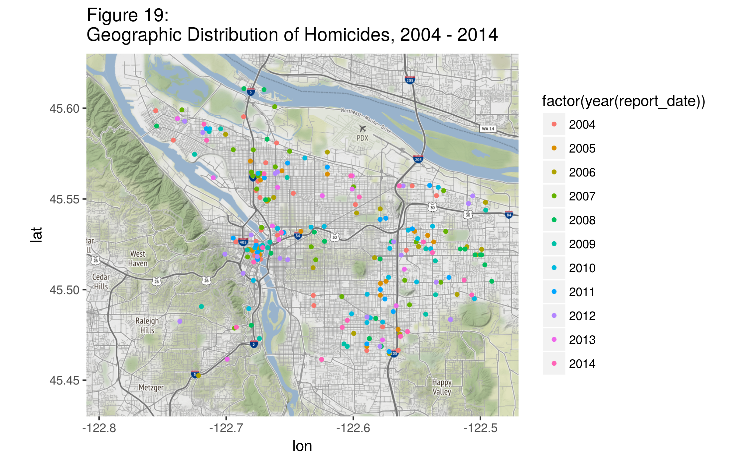

Another offense of interest is Motor Vehicle Theft. This is an offense that is traditionally dominated by male offenders, although some females do participate. Mullins and Cherbonneau conducted an investigation into the habits of people convicted of motor vehicle theft in the St. Louis area and found that female and male methodologies for this particular street crime are fairly similar. They attributed this similarity to the presence of male “gatekeepers” into the world of vehicle theft. While the Portland data offer no insight as to whether a particular offense was committed by male or female perpetrators, the study of these incidents is an interesting one. See Figure 20 for the map. Most of the activity seems to be clustered in the downtown area, though there are pockets of higher activity in other areas of the city as well.

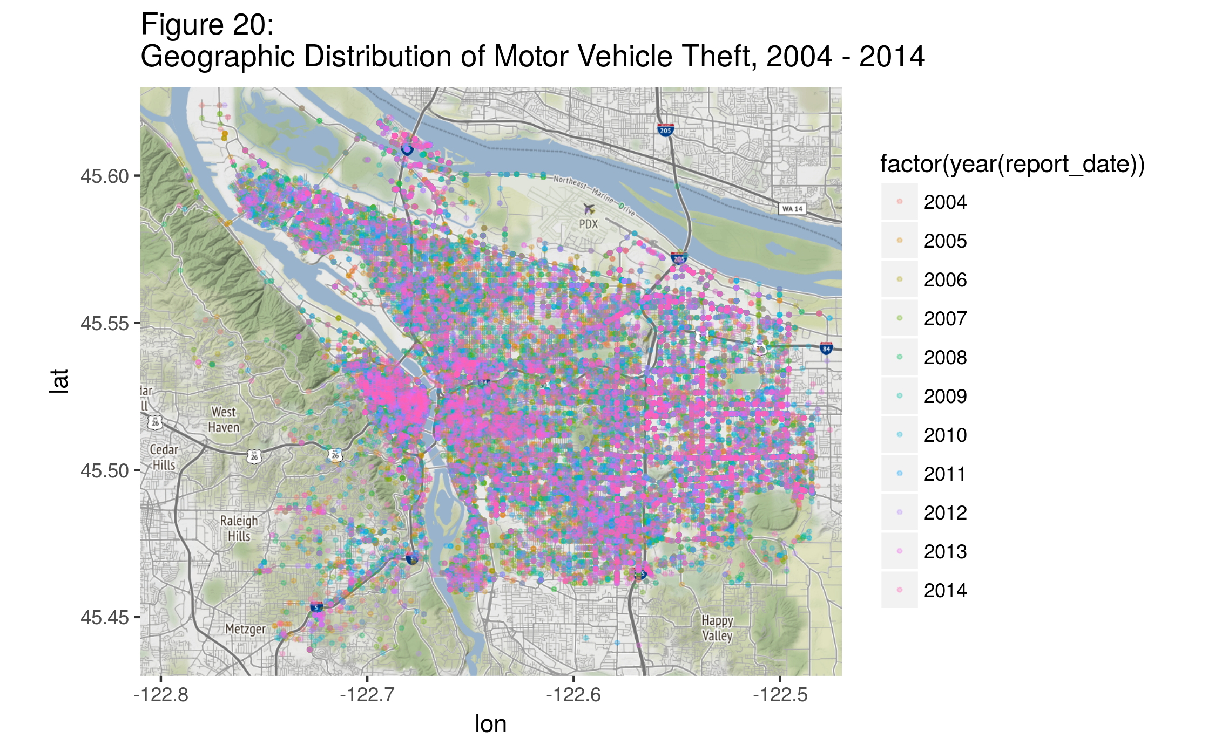

**Segregation and Crime.**

Interestingly, the several broad categories of crimes do not occur with equal frequency among different subpopulations in the United States. For example, young urban minorities are more likely to be arrested for personal and property crimes than other groups. This kind of crime is likely to be reported by local media. Other types of crime, including embezzlement, are committed more frequently by people of high economic standing, and are less likely to be investigated or reported.[12]

O’Flaherty and Sethi conducted interesting research in 2007 examining the relationship between racial segregation and robbery rates.[13] Their fascinating paper postulates that, given a robbery attempt, since whites are perceived as less likely than blacks to resist robbery, whites are also more likely to be targeted by robbers. Because whites are more likely to be targeted, they are also more likely to move to a safer neighborhood if their economic circumstances allow it. Since whites are also, on average, better off economically than blacks, these safer neighborhoods tend to become predominantly white, while the more dangerous neighborhoods tend to become more and more black. “Hence, *conditional on income,* blacks live in more dangerous neighborhoods than whites.”[14]

To determine whether this conclusion held for neighborhoods in Portland, a correlation analysis was completed. Racial demographic information for each of Portland’s ninety-five neighborhoods was collected from the 2010 US Census[15] and compared to the 2010 robbery incident rates reported by the Portland Police Bureau. Some data cleaning was required in order to ensure that the names of each neighborhood matched between the two data sets; for example, while the Census identified one neighborhood as “Lloyd District,” the PPB identified the same area as “Lloyd.” Once this was completed, demographic information from the Census Bureau and the robbery incident data from the PPB was combined into one data set.

Three new statistics were created for each neighborhood: the percentage of people in the neighborhood identified on the 2010 Census as white, the percentage of people identified as black or African American, and the percentage of people who did not identify as white. Interestingly (but not surprisingly: Portland is a notoriously “white” city), the range of households that included people identifying as white in each neighborhood was from 60.1% to 97.0%. The percentage of households with people identifying as other than white was from 6.2% to 50.0%. The percentage of households with people identifying as black or African American ranged from 0.4% to 32.4%.

Next, the correlation coefficient between the percentages listed above and the incidents of Robbery for that year was calculated. The correlation coefficient for “Percentage White” was -0.347, indicating that the correlation between robberies and the percentage of people identifying as white was negatively correlated, but weakly. The correlation for percentage of people who did not identify as white was 0.342, again indicating a weak correlation. The correlation coefficient for the percentage of people identifying as black or African American was even lower: only 0.169. Scatter plots depicting these relationships can be found in Figures 21.

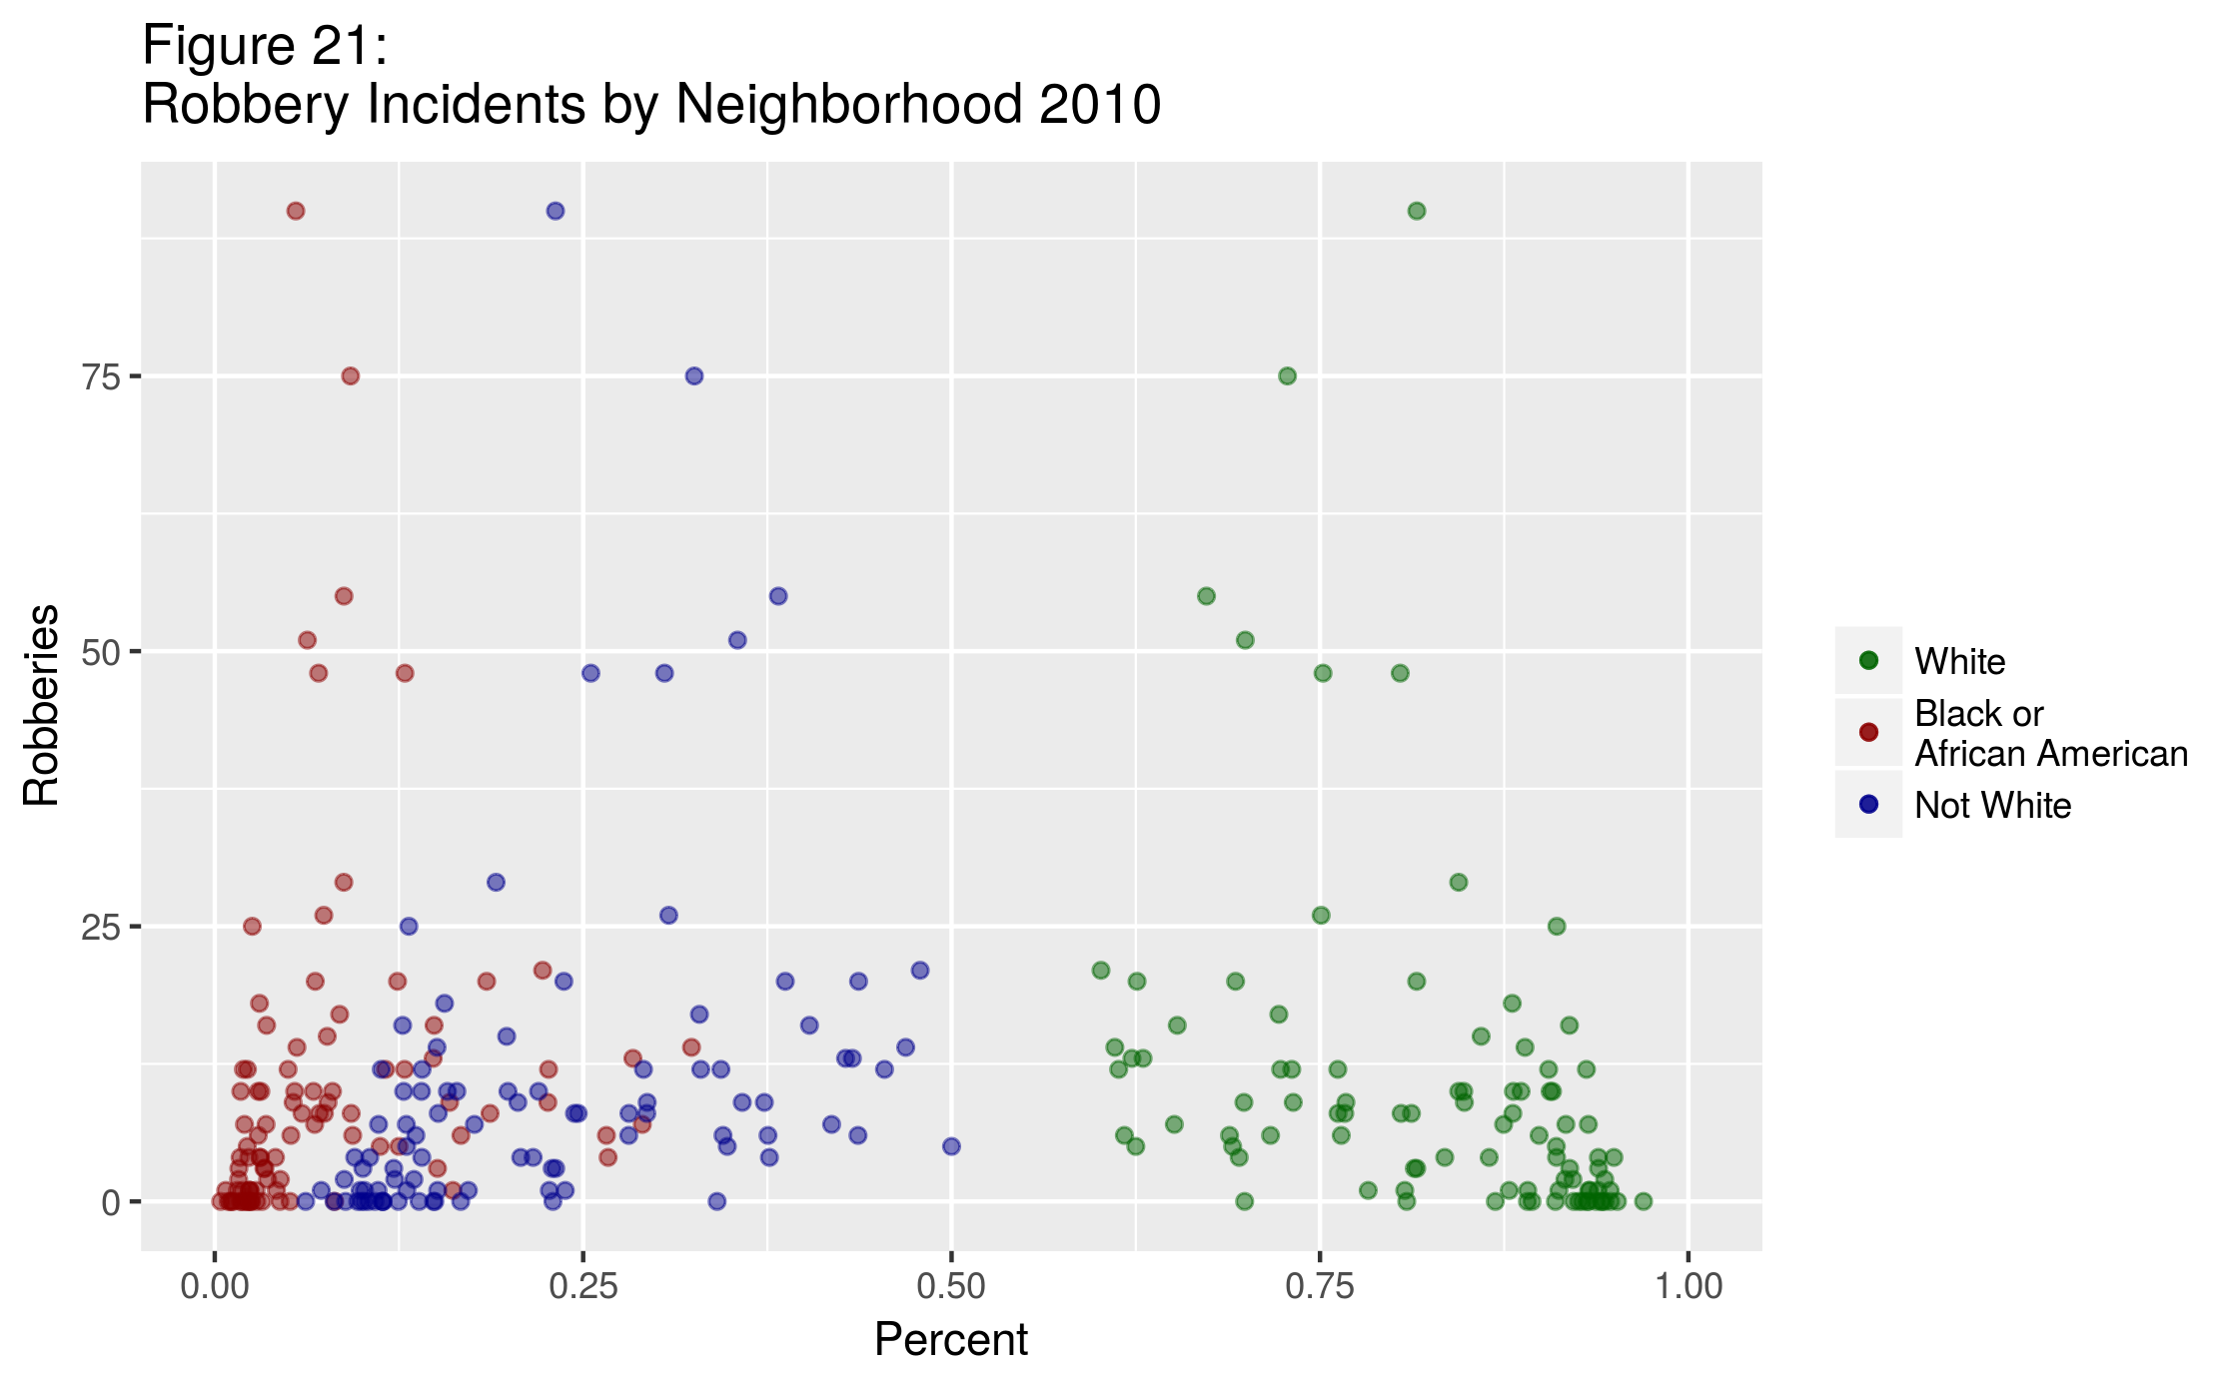These results seem to indicate that O’Flaherty and Sethi’s conclusions do not hold for Portland. Caution is necessary in making this statement, however: their paper’s conclusion included the caveat that the correlation held “*conditional on income.*” Since income information was not available for this project, a complete judgment on their conclusion cannot be made in this case.

Conclusion

Portland, like other cities its size, experiences a certain amount of crime. The data utilized in this project have shown that overall, crime rates in Portland have been decreasing for years. In some respects, the city is safe compared to other cities of a similar size (witness the relatively low homicide rate). In other respects, Portland seems typical of many other cities.

The quality of the data used for this project is admirable. With access to similar data, other cities could identify trends in crime activity and take steps to mitigate areas of concern. For example, neighborhoods with a high incidence of one crime or another may benefit from increased police presence.

Portland’s crime rates are influenced by a number of factors, some of which were examined in this report. First, it was not altogether surprising to find that linear regression models were not very effective in modeling incidence of crime over time. It is true that most offenses did see decreased rates over the course of 2004-2014. However, crime is influenced by a large number of factors; expecting to find a simple relationship with time was probably unrealistic.

Second, a moderately strong negative correlation between the number of liquor law offenses and drug offenses was found. While this was unexpected, it is not altogether outside the realm of possibility. One possible explanation for the correlation is that law enforcement focuses efforts on locating and addressing offenses with one substance, then switches focus to another.

Third, a strong correlation between growth in Portland’s population and a decreased incidence of crime was discovered. This was a surprising result from the perspective of one who assumes that more population gives rise to more crime. Further investigation would be required to try to find possible reasons for this correlation. One such avenue may be to examine the staffing levels and budget allocations of the Portland Police Bureau. Another might be to find information about people in leadership positions in the Bureau and how policies have changed and influenced the number of reports made and taken by officers. Insight might also be gained from inspection of court records and statistics about the area’s jail and prison system. It would be informative to look at crime incidence data from cities of a different size than Portland, and to compare changes in the populations of those cities to their crime incident rates.

Fourth, a low moderate negative relationship was found between the local unemployment level and larceny offenses. This is an interesting finding given the studies that have been conducted indicating a relationship between economic markers and crime rates in general. Further insight into this issue might be gained by examining relative wage levels for the time period. Although the relationship found was not strong, checking state unemployment records for increased benefits provided to unemployed workers during the time period might lend support to the notion that such programs are a benefit to society in general, and not just to those benefiting directly from unemployment programs.

Fifth, it was found that Portland’s robbery rates decreased 22% in the months following the August 2014 events in Ferguson, Missouri. This decrease is in line with decreases seen in other US cities. It would be desirable to study crime rates, including robbery, for 2015 and 2016 as well to verify that this trend continued past the end of 2014, but that data is not yet available.

Finally, it was found that only weak relationships exist between the specific racial demographics of Portland’s neighborhoods and the neighborhood robbery rates. This finding would be supplemented and clarified by information about the economic situation of people living in various neighborhoods in Portland: without that information, information on the racial makeup of a neighborhood has little predictive effect on the robbery rates in the area. Future research would also benefit from a shapefile of the Portland area map that included neighborhood boundaries. This would make it possible to depict any results found on a map, rather than using a scatter/correlation plot as a simple summary figure.

An avenue that would have been interesting to explore further is that of the incidence of crimes in relation to the time of day. Although it was beyond the scope of this project, with the data provided it would be possible to identify crimes that were more likely to be committed in the morning versus the evening. This kind of information might help police departments to allocate their resources, especially human resources, efficiently in their efforts not only to respond to criminal activity, but to be in a position to prevent certain offenses before they are committed.

1. Johnson, 2016.
2. Portland Population History, 2017.
3. BLS, 2012.
4. Shoener, 2017.
5. FBI, 2013.
6. Korn, 2013.
7. Gould, et. al. 2002.
8. BLS, 2012.
9. Pyrooz, 2016.
10. Cahill, 2004, Cahill and Mulligan, 2003, Cahill and Mulligan 2007.
11. Korn, 2013.
12. Crossman, 2017.
13. O’Flaherty and Sethi, 2007.
14. O’Flaherty and Sethi, 2007, p. 392.
15. City of Portland, 2010 Census Data.